AProjectReport on

IMPLEMENTATIONOFGREENLEAFDISEASEDETECTION USINGRASPBERRYPI

Submittedinpartialfulfillmentoftherequirementfortheawardofdegreeof

BACHELOROFTECHNOLOGY in

ELECTRONICSANDCOMMUNICATIONENGINEERING

Submittedby

M.NAGASRIYELESWARI- 18FE1A0471

B.SANDHYARANI - 19FE5A0404

M.RISHITAKALPANA -18FE1A0472

B.PAVANKUMAR - 19FE5A0405

Undertheesteemedguidanceof

Mr.G.HARISHM.Tech.,

AssistantProfessor



DEPARTMENTOFELECTRONICSANDCOMMUNICATIONENGINEERING VIGNAN’SLARAINSTITUTEOFTECHNOLOGY&SCIENCE

(AnISO9001:2008Certified,ApprovedbyAICTE,AffiliatedtoJNTU,KAKINADA)

VADLAMUDI-522213,GUNTURDist.,ANDHRAPRADESH.

2018-2022 i

DEPARTMENTOFELECTRONICSANDCOMMUNICATIONENGINEERING VIGNAN’SLARAINSTITUTEOFTECHNOLOGY&SCIENCE

(AnISO9001:2008Certified,ApprovedbyAICTE,AffiliatedtoJNTU,KAKINADA)

VADLAMUDI-522213,GUNTURDist,ANDHRAPRADESH



CERTIFICATE

Thisistocertifythatmainprojectworkentitled“IMPLEMENTATIONOFGREEN

LEAFDISEASEDETECTIONUSINGRASPBERRYPI”isabonafideworkdoneby

M.NAGASRIYELESWARI(18FE1A0471),B.SANDHYA RANI(19FE1A5A0404), M.RISHITAKALPANA(18FE1A0472)andB.PAVANKUMAR(19FE5A0405),undermy guidanceandsubmittedinpartialfulfillmentofrequirementforawardofdegreeof BachelorofTechnologyinElectronicsandCommunicationEngineeringbyJawaharlal NehruTechnologicalUniversity,Kakinada.

ProjectGuide HeadoftheDepartment

Mr.G.Harish.,M.Tech, Dr.B.Harish(Ph.D)

AssistantProfessor AssistantProfessor

ExternalExaminer

ACKNOWLEDGEMENT ii

Wearemostthankfultoourparentswhostoodaspillarsofmotivation

andforthewaytheyinfluencedandmoldedourlives.

WearemorethankfultoourchairmanDr.LAVURATHAIAHwhohelpedusto haveatechnicalincubationbyprovidingtherequiredinfrastructure.

WeareverymuchthankfultoourprincipalDr.K.PHANEENDRAKUMARwho extendedatimelyhelpateachandeverystepofouracademiccareer.

WeareverythankfultoourHeadofthedepartmentDr.B.HARISHanamicable personwhosupportedusverymuchandhelpedtoamaximumextentandmadethis projectsuccessful.

WeareverythankfultoourbelovedcoordinatorsDr.C.RajaChandraSekaran, Dr.JitendraKumarSaini,Mr.K.VijayaVardhanandMrs.P.SandhyaRani,forinspiring allthewayandarrangingallthefacilitiesandresourcesneededforproject.Theirefforts inthisaspectarebeyondthepreviewoftheacknowledgement.

WeareheartilythankfultoourprojectguideMr.G.HARISH,AssistantProfessor, thepersonwithvibrantknowledgeandamicablebynaturewholaidabestguidelines andfortheeffortsmadebyhimtomaketheprojectasuccessfulone.

Finally,wearethankfultoeachandeveryfacultymembersbothtechnicaland non-technical,friendsandallthepersonswhohelpedusdirectlyorindirectlyinmaking ourprojectasuccessfulone.

ProjectAssociates

M.NAGASRIYELESWARI(18FE1A0471)

|  |  |
| --- | --- |
| B.SANDHYARANI | (19FE5A0404) |
| M.RISHITAKALPANA | (18FE1A0472) |

B.PAVANKUMAR (19FE5A0405)

DECLARATION

iii

Weherebydeclarethattheworkdescribedinthisprojectwork,entitled “IMPLEMENTATIONOFGREENLEAFDISEASEDETECTIONUSINGRASPBERRYPI” whichissubmittedbyusinpartialfulfillmentfortheawardofBachelorofTechnology (B.Tech)intheDepartmentofElectronics&communicationEngineeringtothe Vignan’sLaraInstituteofTechnologyandscienceaffiliatedtoJawaharlalNehru TechnologicalUniversityKakinada,,AndhraPradesh,istheresultofworkdonebyus undertheguidanceofMr.G.HARISH,AssistantProfessor,inthedepartmentECE.

TheworkisoriginalandhasnotbeensubmittedforanyDegree/Diplomaofthis oranyotheruniversity.

M.NAGASRIYELESWARI(18FE1A0471)

B.SANDHYARANI (19FE5A0404)

M.RISHITAKALPANA (18FE1A0472)

B.PAVANKUMAR (19FE5A0405)

Place:Vadlamudi.

Date:

ABSTRACT

iv

Forthedetectionandpreventionofdiseaseofplantsfromgettingspread,this projectproposed asystemusingimageprocessing.Fortheimageanalysis, ConventionalNeuralNetworkswasused.Ithasmanyadvantagesfortheuseinbig farmsofcropsandthusitautomaticallydetectssignsofdiseasewhenevertheyappear onleavesoftheplant.Inpharmaceuticalresearchofleafdiseasedetectionis necessaryandimportanttopicforresearchbecauseithasadvantagesinmonitoring cropsinfieldattheformandthusitautomaticallydetectsymptomsofdiseaseby imageprocessingbyCNNalgorithm.Thetermdiseasemeansthetypeofdamageto theplants.Thisprojectprovidesthebestmethodfordetectionofplantdiseasesusing imageprocessingandalertingaboutthediseasecausedbysendingtoIoTServerand displayingthenameofthediseaseandprecautionsonthemobileapplicationofthe ownerofthesystem..Itwillreducethecostrequiredforthepesticidesandother products.Thiswillleadtoincreaseinproductivityofthefarming.

.IndexTerms—ImageProcessing,IoT,Python.

|  |  |  |  |
| --- | --- | --- | --- |
| CONTENTS |  | PAGENO. | |
| ABSTRACT |  |  | iv |
| CHAPTER1:INTRODUCTION |  |  | 01-03 |
| CHAPTER2:LITERATURESURVEY |  |  | 04-05 |
| CHAPTER3:EXISTINGSYSTEM | 06-12 |  |  |
| 3.1Existingsystem1  3.1.2BlockDiagram  3.1.3Description  3.1.4Advantages  3.1.5Disadvantages |  |  | 06 |
| 3.1.6Applications  3.2Existingsystem2  3.2.1BlockDiagram  3.2.2Description  3.2.3Disadvantages |  | 07 |  |
| CHAPTER4:PROPOSEDSYSTEM |  |  | 07 |
| 4.1Objective |  | 07 |  |

4.2Diseases

4.3CNNAlgorithm

|  |  |
| --- | --- |
| CHAPTER5:HARDWAREANDSOFTWAREDESCRIPTION | 13-31 |
| CHAPTER6:RESULTSANDDISCUSSION  CONCLUSION  FUTURESCOPE | 32 |
| REFERENCES | 39 |
| APPENDIX | 38 |

CHAPTER-1

INTRODUCTION

AgricultureisthemainstayoftheIndianeconomy.negativeeffectonour environment.Theuseofchemicalpesticideshasledtoenormouslevelsofchemical buildupinourenvironment,insoil,water,air,inanimalsandeveninourownbodies. Artificialfertilizersgivesonashort-termeffectonproductivitybutalonger-term negativeeffectontheenvironment,wheretheyremainforyearsafterleachingand runningoff,contaminatinggroundwater.Anothernegativeeffectofthistrendhasbeen onthefortunesofthefarmingcommunitiesworldwide.Despitethisso-calledincreased productivity,farmersinpracticallyeverycountryaroundtheworldhaveseenadownturn intheirfortunes.Thisiswhereorganicfarmingcomesin.Organicfarminghasthe capabilitytotakecareofeachoftheseproblems.Thecentralactivityoforganicfarming reliesonfertilization,pestanddiseasecontrol.

Plantdiseasedetectionthroughnakedeyeobservationofthesymptomsonplant leaves,incorporaterapidlyincreasingofImmensecommercializationofanagriculture hascreatesaverycultivatedCropsandtheirexistingpsychopathologicalproblems, evenexperiencedagriculturalexpertsandplantpathologistsmayoftenfailto successfullydiagnosespecificdiseases,andareconsequentlyledtomistaken conclusionsandconcernsolutions.Anautomatedsystemdesignedtohelpidentify plantdiseasesbytheplant’sappearanceandvisualsymptomscouldbeofgreathelpto amateursintheagriculturalprocess.Thiswillbeproveasusefultechniqueforfarmers andwillalertthemattherighttimebeforespreadingofthediseaseoverlargearea.

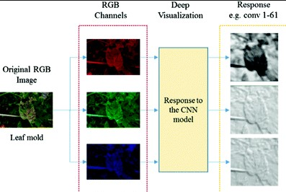

Fig.1AnalysisofCNNalgorithm

Deeplearningconstitutesarecent,moderntechniqueforimageprocessinganddata analysis,withaccurateresultsandlargepotential.Asdeeplearninghasbeen successfullyappliedinvariousdomains,ithasrecentlyenteredalsothedomainof agriculture.Sowewillapplydeeplearningtocreateanalgorithmforautomated detectionandclassificationofplantleafdiseases.Nowadays,ConvolutionalNeural Networksareconsideredastheleadingmethodforobjectdetection.Inthispaper,we considereddetectorsnamelyFasterRegion-BasedConvolutionalNeuralNetwork (FasterR-CNN),Region-basedFullyConvolutionalNetworks(R-FCN)andSingleShot MultiboxDetector(SSD).Eachofthearchitectureshouldbeabletobemergedwithany featureextractordependingontheapplicationorneed.Weconsidersomeofthe

ommercial/cashcrops,crealcrops,andvegetablecropsandfruitplantssuchas sugarcane,cotton,potato,carrot,chilly,brinjal,rice,wheat,bananaandguava,these leavesimagesareselectedforourpurpose.Fig.1showsimagesofthediseased affectedleavesonvariouscrops.Theearlydetectionofplantleafdiseasescouldbea valuablesourceofinformationforexecutingproperdiseasesdetection,plantgrowth managementstrategiesanddiseasecontrolmeasurestopreventthedevelopmentand thespreadofdiseases.

CHAPTER-2

LITERATURESURVEY

Inthissectiondescribesvariousapproachesfordetectingthediseaseinplantleaf usingimageprocessingtechnique

SachinD.Khirade&etal…[1]Identificationoftheplantdiseasesisthekeyto preventingthelossesintheyieldandquantityoftheagriculturalproduct.Itrequires tremendousamountofwork,expertizeintheplantdiseases,andalsorequirethe excessiveprocessingtime.Hence,imageprocessingisusedforthedetectionofplant diseases.Diseasedetectioninvolvesthestepslikeimageacquisition,imagepreprocessing,imagesegmentation,featureextractionandclassification.Thispaper discussedthemethodsusedforthedetectionofplantdiseasesusingtheirleaves images.Thispaperdiscussedvarioustechniquestosegmentthediseasepartofthe plant.ThispaperalsodiscussedsomeFeatureextractionandclassificationtechniques toextractthefeaturesofinfectedleafandtheclassificationofplantdiseases.The accuratelydetectionandclassificationoftheplantdiseaseisveryimportantforthe successfulcultivationofcropandthiscanbedoneusingimageprocessing.Thispaper discussedvarioustechniquestosegmentthediseasepartoftheplant.Thispaperalso discussedsomeFeatureextractionandclassificationtechniquestoextractthefeatures ofinfectedleafandtheclassificationofplantdiseases.TheuseofANNmethodsfor classificationofdiseaseinplantssuchasself-organizingfeaturemap,back propagationalgorithm,SVMsetc.canbeefficientlyused.Fromthesemethods,wecan accuratelyidentifyandclassifyvariousplantdiseasesusingimageprocessing technique.

Prof.Sanjay,B.Dhaygude&etal…[2]Theapplicationoftexturestatisticsfor detectingtheplantleafdiseasehasbeenexplainedFirstlybycolortransformation structureRGBisconvertedintoHSVspacebecauseHSVisagoodcolordescriptor. Maskingandremovingofgreenpixelswithpre-computedthresholdlevel.ThenintheA

LiteratureSurvey:PlantLeafDiseasesDetectionUsingImageProcessingTechniques DOI:10.9790/2834-1203021315 www.iosrjournals.org 14 |Pagenextstep segmentationisperformedusing32X32patchsizeandobtainedusefulsegments. Thesesegmentsareusedfortextureanalysisbycolorco-occurrencematrix.Finallyif textureparametersarecomparedtotextureparametersofnormalleaf.

AmandeepSingh,ManinderLalSingh&etal…[3]Themostsignificantchallenge facedduringtheworkwascapturingthequalityimageswithmaximumdetailoftheleaf color.Itisverytypicaltasktogettheimagewithallthedetailswithinaprocesable memory.Suchimagesareformedathroughhighresolutionandthusareof6-10MBof size.ThiswashandledbyusingaNikonmadeD5200camerawhichservedthetask verywell.Secondchallengefacedwastogetridofilluminationconditionsasfromthe starttotheendofpaddycropseason,illuminationvariesalotevenwhentheimage acquiringtimeisfixed.Howeverthesolutiontothisisvariableuserdefinedthresholding andmakingnecessaryadjustmentstotheshadesofLCC.

M.Malathi,K.Aruli&etal…[4]Theyprovidessurveyonplantleafdiseasedetection usingimageprocessingtechniques.Diseaseincropscausessignificantreductionin quantityandqualityoftheagriculturalproduct.Identificationofsymptomsofdisease bynakedeyeisdifficultforfarmer.Cropprotectionespeciallyinlargefarmsisdoneby usingcomputerizedimageprocessingtechniquethatcandetectdiseasedleafusing colorinformationofleaves.Dependingontheapplications,manyimageprocessing techniquehasbeenintroducedtosolvetheproblemsbypatternrecognitionandsome automaticclassificationtools.Inthenextsectionthispaperspresentasurveyofthose proposedsystemsinmeaningfulway.Therearemanymethodsinautomatedor omputervisionfordiseasdetectionandclassificationbutstillthereislackinthis

researchtopic.Allthediseasecannotbeidentifiedusingsinglemethod.

MalvikaRanjan,ManasiRajivWeginwar&etal…[5]Describesadiagnosisprocess thatismostlyvisualandrequiresprecisejudgmentandalsoscientificmethods.Image ofdiseasedleafiscaptured.AstheresultofsegmentationColorHSVfeaturesare extracted.Artificialneuralnetwork(ANN)isthentrainedtodistinguishthehealthyand diseasedsamples.ANNclassificationperformanceis80%betterinaccuracy.

Y.Sanjana,AshwathSivasamy&etal…[6]Inthisitdescribestheuploadedpictures capturedbythemobilephonesareprocessedintheremoteserverandpresentedtoan expertgroupfortheiropinion.Computervisiontechniquesareusedfordetectionof affectedspotsfromtheimageandtheirclassification.Asimplecolordifferencebased approachisfollowedforsegmentationofthediseaseaffectedlesions.Thesystem allowstheexperttoevaluatetheanalysisresultsandprovidefeedbackstothefamers throughanotificationtotheirmobilephones.Thegoalofthisresearchistodevelopan imagerecognitionsystemthatcanrecognizecropdiseases.Imageprocessingstarts withthedigitizedcolorimageofdiseaseleaf.Amethodofmathematicsmorphologyis usedtosegmenttheseimages.Thentexture,shapeandcolorfeaturesofcolorimage ofdiseasespotonleafwereextracted,andaclassificationmethodofmembership functionwasusedtodiscriminatebetweenthethreetypesofdiseases.

BhumikaS.Prajapati,VipulK.Dabhi&etal…[7]Inthisdetectionandclassificationof cottonleafdiseaseusingimageprocessingandmachinelearningtechniqueswas carriedout.Alsothesurveyonbackgroundremovalandsegmentationtechniqueswas discussed.Throughthissurvey,weconcludedthatforbackgroundremovalcolorspace conversionfromRGBtoHSVisuseful.Wealsofoundthatthresholdingtechniquegives goodresultcomparedtootherbackgroundremovaltechniques.Weperformedcolor segmentationbymaskinggreenpixelsinthebackgroundremovedimageandthen applyingthresholdingontheobtainedmaskedimagetogetbinaryimage.Thisisuseful toextractaccuratefeaturesofdisease.WefoundthatSVMgivesgoodresults,interms ofaccuracy,forclassificationofdiseases.Therearefivemajorstepsinourproposed work,outofwhichthreestepshavebeenimplemented:ImageAcquisition,Imagepreprocessing,andImagesegmentation.

P.Revathi,M.Hemalatha&etal…[8]ThisproposedworkisbasedonImageEdge detectionSegmentationtechniquesinwhich,thecapturedimagesareprocessedfor enrichmentfirst.ThenR,G,BcolorFeatureimagesegmentationiscarriedouttoget targetregions(diseasespots).Later,imagefeaturessuchasboundary,shape,color andtextureareextractedforthediseasespotstorecognizediseasesandcontrolthe pestrecommendation.InthisResearchworkconsistthreepartsofthecottonleafspot, cottonleafcolorsegmentation,EdgedetectionbasedImagesegmentation,analysis andclassificationofdisease.

Mr.PramodS.landge,SushilA.Patil&etal…[9]Inthisproposeandexperimentally evaluateasoftwaresolutionforautomaticdetectionandclassificationofplant diseasesthroughImageProcessing.FarmersinruralIndiahaveminimalaccessto agriculturalexperts,whocaninspectcropimagesandrenderadvice.Delayedexpert responsestoqueriesoftenreachfarmerstoolate.Thispaperaddressesthisproblem withtheobjectiveofdevelopingimageprocessingalgorithmsthatcanrecognize problemsincropsfromimages,basedoncolour,textureandshapetoautomatically detectdiseasesorotherconditionsthatmightaffectcropsandgivethefastand accuratesolutionstothefarmerwiththehelpofSMS.Thedesignandimplementation ofthesetechnologieswillgreatlyaidinselectivechemicalapplication,reducingcosts andthusleadingtoimprovedproductivity,aswellasimprovedproduce.

HeebAlBashish,MalikBraik&etal…[10]Inthispaperanimage-processing-based approachisproposedandusedforleafandstemdiseasedetection.Wetestour programonfivediseaseswhicheffectontheplants;theyare:Earlyscorch,Cottony mold,ashenmold,latescorch,tinywhiteness.Theproposedapproachisimageprocessing-based.Inthefirststepoftheproposedapproach,theimagesathandare segmentedusingtheKMeanstechnique,inthesecondstepthesegmentedimagesare passedthroughapre-trainedneuralnetwork.Asatestbedweuseasetofleafimages takenfromAl-GhorareainJordan.

SatishMadhgoria,MarekSchikora&etal…[11]Proposedautomaticpixelbased lassificationmethodfordtectingunhealthyregionsinleafimagesispresented.The algorithmshavebeentestedextensively.LinearSVMhasbeenusedtoclassifyeach pixel.WehavealsoshownhoetheresultsfromSVMcouldbeimprovedremarkably usingtheneighborhoodchecktechnique.Thepresentedalgorithmcouldwellextended forotherdetectiontaskswhichalsomainlyrelyoncolorinformation,butextensionto otherfeaturesiseasilypossible.Thetaskisperformedinthreesteps.First,weperform segmentationtodividetheimageintoforegroundandbackground.Inthesecondstep, supportvectormachinesareappliedtopredicttheclassofeachpixelbelongingtothe foreground.Andfinally,wedofurtherrefinementbyneighborhood-checktoomitall falsely-classifiedpixelsfromsecondstep.

CHAPTER3

EXISTINGSYSTEM

Objective

Themainfocusofthisprojectistoprovidea softwaresolutionforautomaticdetectionand classificationofplantleafdisease.Wewilldetect thediseaseofplantbyusingArtificialNeural Networkalgorithm.

B

l

o

c

k

D

i

a

g

r

a

m

P

O

W

E

R

S

U

P

P

L

Y

R

A

S

P

B

E

R

R

Y

P

I

3

B

+

M

O

D

U

L

E

(

A

N

N

)

M

O

N

I

T

O

R

D

I

S

P

L

A

Y

C

A

M

R

E

A

Description

Theoverallconceptthatistheframeworkforany visionrelatedalgorithmofimageclassificationis almostthesame.First,thedigitalimagesare acquiredfromtheenvironmentusingadigital camera.Thenimage-processingtechniquesare appliedtotheacquiredimagestoextractuseful featuresthatarenecessaryforfurtheranalysis. After that,severalanalyticaldiscriminating techniquesareusedtoclassifytheimages accordingtothespecificproblemathand.Figure1 depictsthebasicprocedureoftheproposedvisionbaseddetectionalgorithminthisresearch.

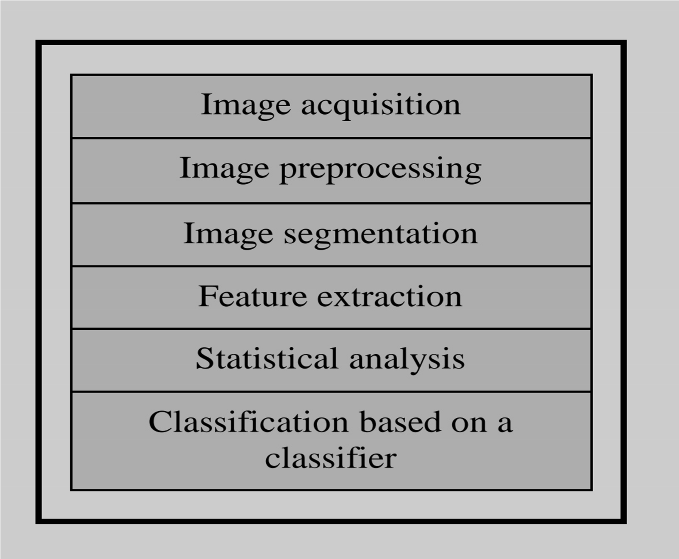

Figure1:Thebasicprocedureoftheproposed imageprocessing-baseddiseasedetectionsolution

The proposed approach step-by-step of the image segmentation and recognitionprocessesiillustrated inAlgorithm1.

Intheinitialstep,theRGBimagesofalltheleafsampleswerepickedup.Somereal samplesofthosediseasesareshowninFigure2.

It isobviousfromFigure2thatleavesbelongingto earlyscorch,cottonymold,ashenmoldandlate scorchhavesignificantdifferencesformgreasspot leavesintermsofcolorandtexture.

Also,Figure3 showstwoimages;theleftimageisinfectedwith tinywhitenessdisease,andtherightimageisa normalimage.

However,theleavesrelatedtothese sixclasses(earlyscorch,cottonymold,ashenmold, latescorch,tinywhitenessandnormal)hadvery smalldifferencesasdiscernibletothehumaneye, whichmayjustifythemisclassificationsbasedon nakedeye. Algorithm1:Basicstepsdescribingtheproposed algorithm.

1RGBimageacquisition

2Createthecolortransformationstructure

3ConvertthecolorvaluesinRGBtothespace specifiedinthecolortransformationstructure

4ApplyK-meansclustering

5Maskinggreen-pixels

6Removethemaskedcellsinsidetheboundaries oftheinfectedclusters

7Converttheinfected(cluster/clusters)formRGB toHSITranslation

8SGDMMatrixGenerationforHandS

9CallingtheGLCMfunctiontocalculatethe features

10TextureStatisticsComputation 11ConfiguringNeuralNetworksforRecognition

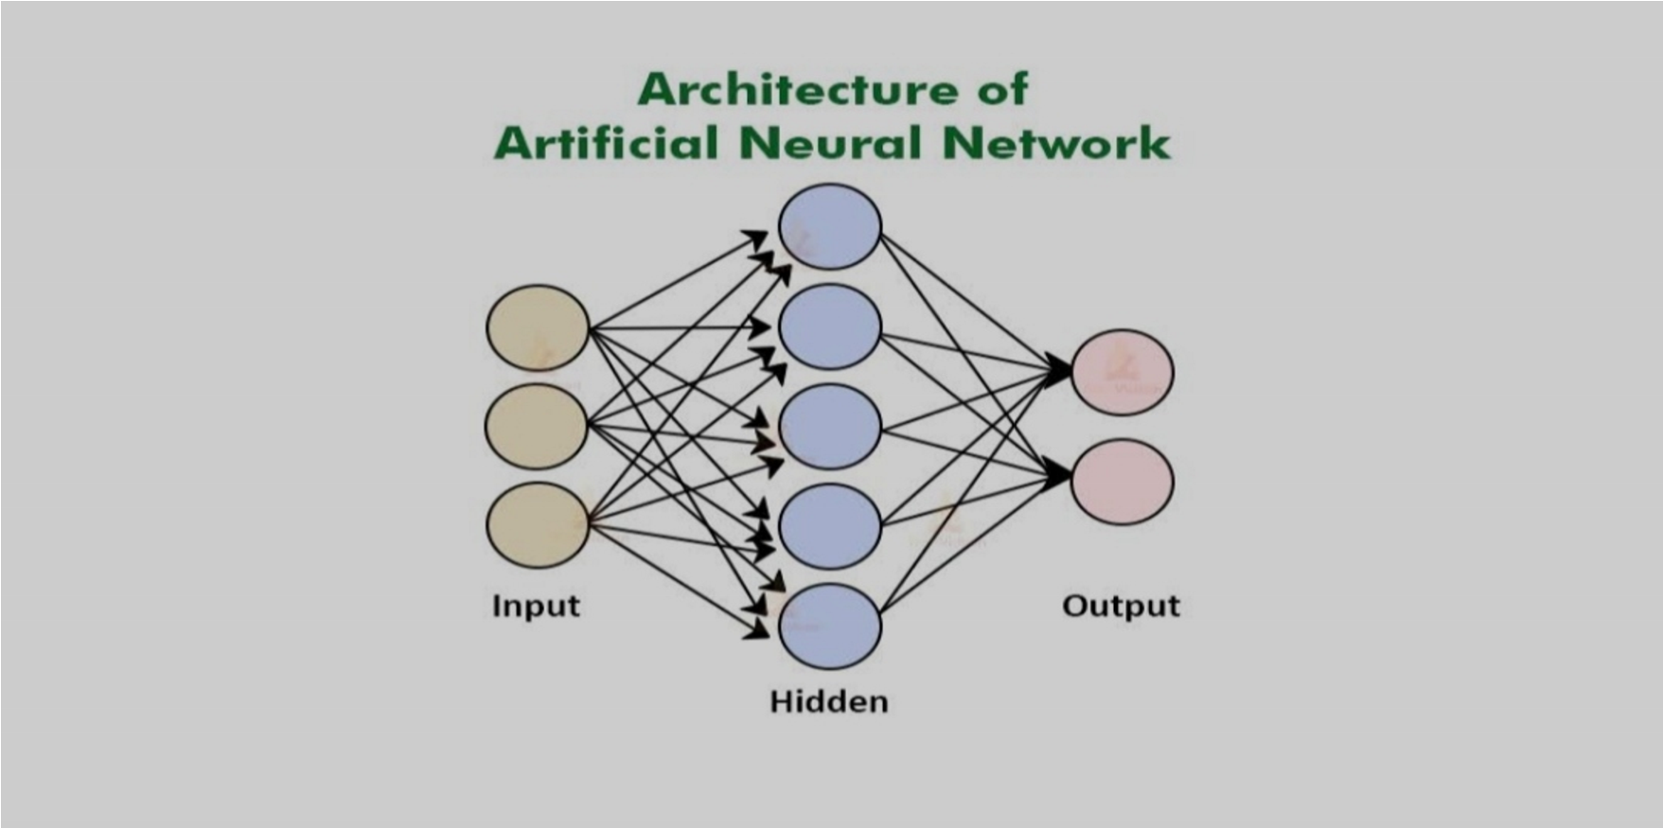

Figure:ArchitectureofANNAlgorithm

Advantages

.Itisusedtodetectplantdiseases

.Itgivesaccurateresults

Disadvantages

.Itincreasescomplexity

.Itrequiresmorepowerfulprocessortoprocess

CHAPTER-4

PROPOSEDMETHODOLOGY

Plantsaresusceptibletoseveraldisordersandattackscausedbydiseases.There areseveralreasonsthatcanbecharacterizabletotheeffectsontheplants,disorders duetotheenvironmentalconditions,suchastemperature,humidity,nutritionalexcess orlosses,lightandthemostcommondiseasesthatincludebacterial,virus,andfungal diseases.Thosediseasesalongwiththeplantsmayshowsdifferentphysical characteristicsontheleaves,suchasachangesinshapes,colorsetc.Duetosimilar patterns,thoseabovechangesaredifficulttobedistinguished,whichmakestheir recognitionachallenge,andanearlierdetectionandtreatmentcanavoidseverallosses inthewholeplant.Inthispaper,wearediscussedtouserecentdetectorssuchas FasterRegion-BasedConvolutionalNeuralNetwork(FasterR-CNN),Region-basedFully ConvolutionalNetworks(R-FCN)andSingleShotMultiboxDetectortodetectionand classificationofplantleafdiseasesthataffectinvariousplants.Thechallengingpartof ourapproachisnotonlydealwithdiseasedetection,andalsoknowntheinfection statusofthediseaseinleavesandtriestogivesolution(i.e.,nameofthesuitable organicfertilizers)forthoseconcerndiseases.

2.2DISEASES

Leafminersaretheinsectfamilyatlarvalstage.Theyfeedbetweenupperand lowerpartoftheleaf.

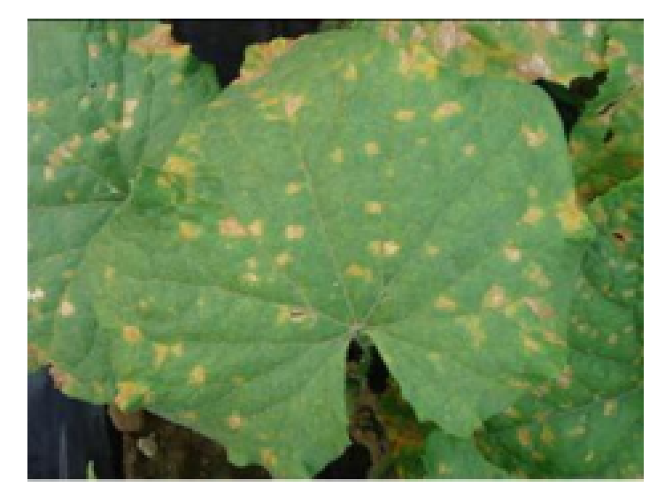

Fig3:Leafminerdisease

Duetoinsectonverymuchamountinplant,itisseverelydamaged.Onasingle leafthenumberofmaggotscanbesix.Therefore,itcanseverelydamagetheleafof plant.Itcanrestrictplantgrowth,leadstoreducedyields.

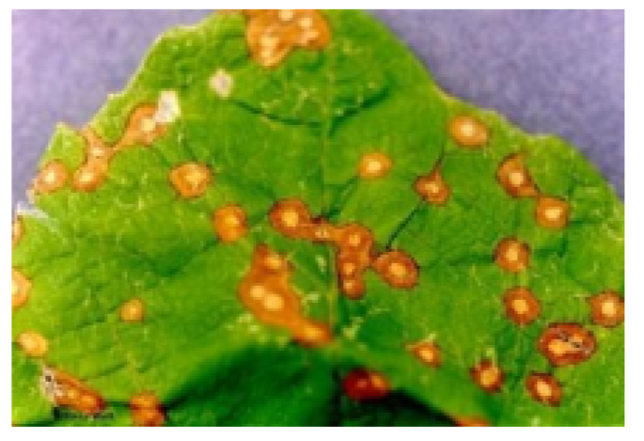

Fig4:YellowSpotDisease

Hencewecandevelopatechniqueusingimageprocessingtodetectthedisease, toclassifyit.Thiswillavoidhumaninterferenceandhenceleadtoprécised unprejudiceddecision.Generally,whateverourobservationaboutthediseaseisjust usedforthedecisionofthedisease.Asymptomofplantdiseaseisavisibleeffectof diseaseontheplant.Symptomscanbechangeincolor,changeintheshapeor functionalchangesoftheplantasperitsresponsetothepathogens,insectsetc.Leaf wiltingisacharacteristicsymptomofverticiliumwilt.Itiscausedduetothefungal plantpathogensV.dahliaeandVerticilliumalboatrum.Generalcommonbacterial diseasesymptomsarebrown,necroticlesionswhichgetssurroundedbyabrightlight yellowhaloattheedgeoftheleafoftheplantoratinnerpartoftheleafonthebean plants.Youarenotactuallyseeingthediseasepathogen,butratherasymptomthatis beingcausedbythepathogen.

4.IMAGEPROCESSINGALGORITHM

1.CapturetheimageinRGBformat.

2.Generatecolortransformationstructure.

3.ConvertcolorvaluesfromRGBtothespacespecifiedinthatstructure.

4.ApplyKmeansclusteringforimagesegmentation.

5.Maskingofgreenpixels(maskinggreenchannel).

6.Eliminatethemaskedcellspresentinsidetheedgesoftheinfectedcluster.

7.ConverttheinfectedclusterfromRGBtoHIS.

8.GenerationofSGDMmatrixforHandS.

9.CallingGLCMfunctioninordertocalculatethefeaturesofit.

10.Computationoftexturestatistics

11.Configurecnn(classifier)forrecognition

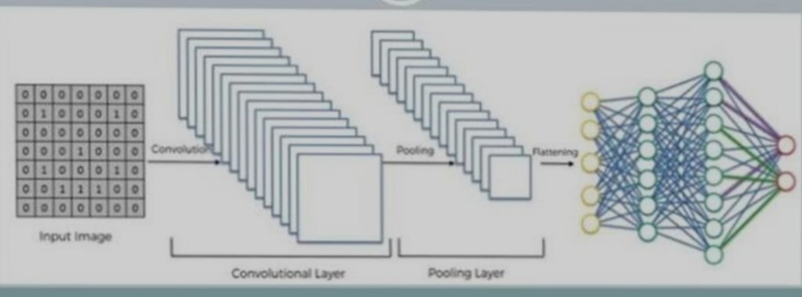

Advantages

.Increaseinformproductivity.

.Moreaccuracy.

Application

.Itcanbeusedinfarmingandgardeningpurposestodetectdiseases.

5.SOFTWARETECHNOLOGIES

1.OpenCV

OpenCVstandsforOpenSourceComputerVision.Itismachinelearningsoftware library.Itcontainslibraryofprogrammingfunctions.OpenCVisrequiredforrealtime applicationsrelatedwithimageprocessing.OpenCVismostlywritteninC,C++ languagesanditsmajorinterfaceisinC++language,howeveritstillretainsaless widespreadthoughverymuchwideinterfacewithClanguage.

2.Python

Pythonismodest,easytolearn.Itisrequiredfortheprogrammingofcoderelatedto raspberryPi.Pythonisalanguagethatsupportsmodulesaswellaspackages.Alsoit hasaPythoninterpreteralongwiththestandardlibrary.Theyareavailableinboth sourceaswellasbinaryformforfreetoallplatforms,andcanbefreelydistributedtoall. PythonisascriptingLanguagethatmeansitallowstoexecutethecodelinebyline.

3.Thingspeakserver

Therearetwotypesofservers.1.Applicationserver2.WebserverItisanopensource webserverthatisdevelopedMATLABFoundation.Inoursystemthedatabasecontains imagesoftheinfectedandhealthyleavestakenfromvariousangles.Thisdatabaseis large.Alsoforimageprocessing,someprocessesneedjavabasedsystems.

CHAPTER5

HARDWARECOMPONENT

5.1Raspberrypi

ItisamodifiedformofitspredecessorRaspberryPi3Bthatwasintroducedin2016andcame withCPU,GPU,USPportsandI/Opins.Bothversionsarealmostsameintermsoffunctionality andtechnicalspecifications;however,therearesomeexceptionsintheB+modelasitcomes withUSBboot,networkboot,andPoweroverEthernetoptionthatarenotpresentintheBmodel.

Technologyhasbeenevolvedovertimewiththepurposeofmakingliveseasyandconvenient. Thisdevicewasamajordevelopmentinthetechnologythatmadecomputerlearningtooeasy thatanyonewithlittleeffortcanmaketheirfeetwetwiththeprocess.

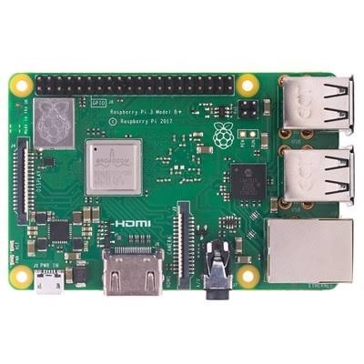

RaspberryPi3B+wasintroducedbyRaspberryPifoundationon 14thMarch2018.ItisanadvancedversionofRaspberryPi3B modelthatwasintroducedin2016.

ItisatinycomputerboardthatcomeswithCPU,GPU,USBports, I/Opins,WiFi,Bluetooth,USBandnetworkbootandiscapable ofdoingsomefunctionslikearegularcomputer.

FeaturesoftheB+versionarealmostsameasBmodel; however,USBandNetworkBootandPoweroverEthernetfacility onlycomewithB+model.Also,twoextraUSBportsareaddedto thisdevice.

TheSoC(systemonchip)combinesbothCPUandGPUona singlepackageandturnsouttobefasterthanPi2andPi3 models.

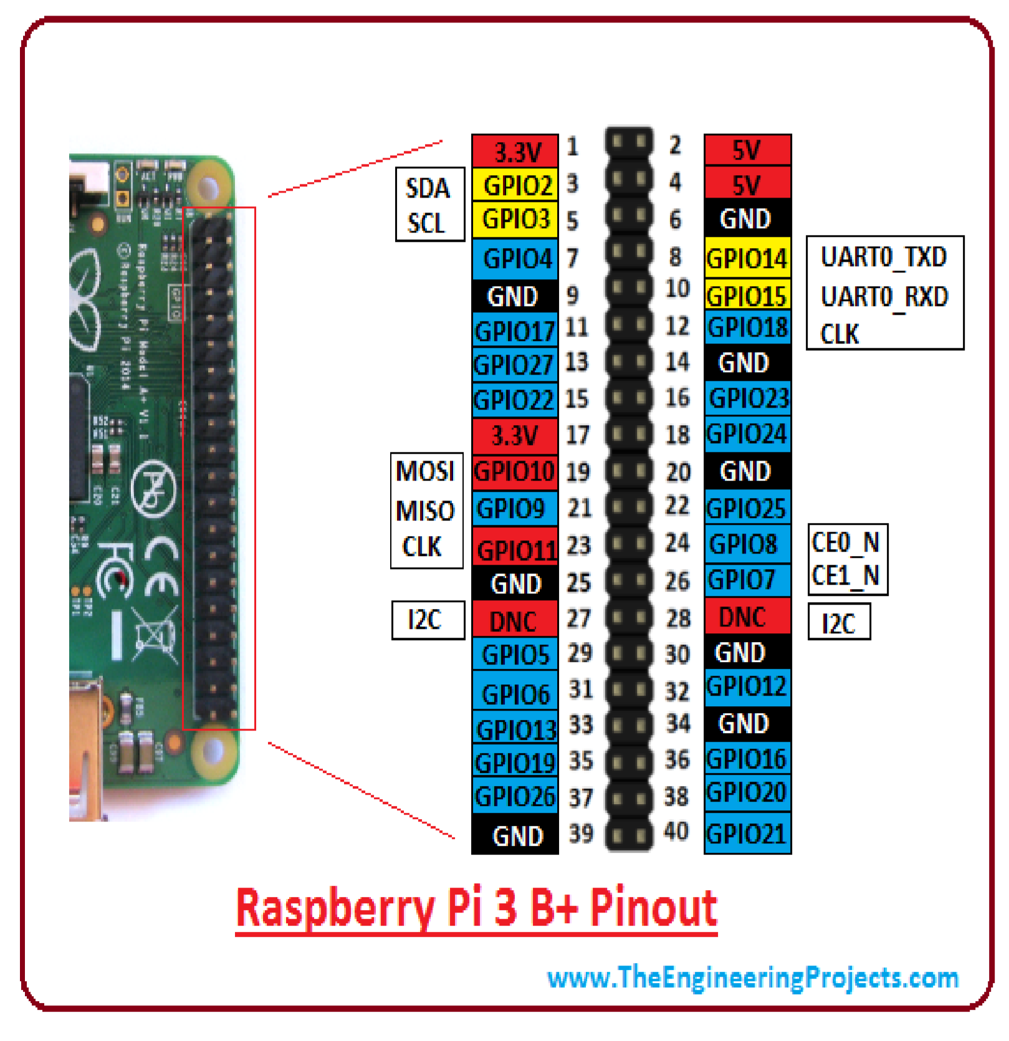

40Pinheaderisusedtodevelopanexternalconnectionwiththe electronicdevice.Thisisthesameasthepreviousversions, makingitcompatiblewithallthedeviceswhereolderversions canbeused.

Outof40pins,26areusedasadigitalI/Opinsand9ofthe remaining14pinsaretermedasdedicatedI/Opinswhich indicatetheydon’tcomewithalternativefunction.

Pin3and5comeswithanonboardpullupresistorwhich1.8kΩ andPin27and28arededicatedtoIDEEPROM.InB+modelthe GPIOheaderisslightlyrepositionedtoallowmorespaceforthe additionalmountinghole.Thedevicesthatarecompatiblewith theBmodelmayworkwiththeB+version;however,theymay notsitidenticallytothepreviousversion.

HardwareSpecifications

CPU:TheCPUisabrainofthistinycomputerthathelpsin carryingoutanumberofinstructionbasedonthemathematical andlogicalformulas.Itcomeswithacapacityof64bit.

ClockSpeedandRAM:Itcomeswithaclockspeedof1.4GHz

BroadcomBCM2837B0thatcontainsquad-coreARMCortexA53andRAMmemoryisaround1GB(identicaltotheprevious version)

GPU:Itstandsforgraphicsprocessingunit,usedforcarryingout imagecalculation.Broadcomvideocorecableisaddedinthe devicethatismainlyusedforplayingvideogames.

USBPorts:TwomoreUSBportsareintroducedinthisnew version,settingyoufreefromthehassleofusinganexternal USBhubwhenyouaimtojoinanumberofperipheralswiththe device.

MicroUSBPowerSourceConnector:Thisconnectorisusedfor providing5Vpowertotheboard.Itdraws170to200mAmore powerthanBmodel.

HDMIandCompositeConnection:Bothaudiooutputsocketand videocompositenowresideinasingle4-pole3.5mmsocket whichresidesnearHDMI.Andthepowerconnectorisalso repositionedinnewB+modelandlivesnexttoHDMIsocket.All thepowerandaudiovideocompositesocketarenowplacedon theonesideofthePCB,givingitacleanandpreciselook.

USBHardDrive:TheUSBharddriveisavailableontheboardthat isusedtobootthedevice.Itisidenticaltotheharddriveof regularcomputerwherewindowsisusedtoboottheharddrive ofthecomputer.

PoE:B+modelcomeswithafacilityofPoweroverEthernet (PoE);anewfeatureaddedinthisdevicewhichallowsthe necessaryelectricalcurrentusingdatacables.

OtherChanges:TheB+versioncomeswithlittleimprovementin thefeaturesandposesslightlydifferentlayoutintermsof locationofthecomponents.TheSDmemoryslotisreplacedby amicroSDmemorycardslot(workssimilartotheprevious version).ThestatusLEDsnowonlycontainredandgreencolor andrelocatedtotheoppositeendofthePCB.

RaspberryPi3B+TechnicalSpecifications

CPUis64bitwith1GBRAM(randomaccessmemory)

ContainsBroadcomBCM2837B0chipset

Comeswith1.4GHzQuad-CoreARMCortex-A53,4cores

Consistsof40pinheader(26GPIOs)

Stereoaudioandcompositevideoissupportedby3.5mmjack connector

4USB2.0ports

GigabitEthernet

PoE(poweroverEthernet)isamajorfeatureincorporatedinthis devicethatlacksinBmodel

2-pinresetheader

MicroSDsocket,usedtoenhancethememorycapacityofthe board

MicroUSBpowerconnector,usedfortransferringpowertothe device

HDMI

CSIcamerainterface

ComeswithWiFiandBluetoothfacilitythatwerenotpresentin previousRaspberryPi1and2versions

DSIconnectorforofficialscreen

ApplicationsofRaspberryPi:

RaspberryPicomeswithawiderangeofapplicationsandworks asaregularcomputerinsomecases.

TabletComputer

HomeAutomation

ControllingRobots

CoffeeProjects

ArcadeMachine

MediaStreamer

InternetRadio

CosmicComputer

5.2CameramoduleofRaspberryPi

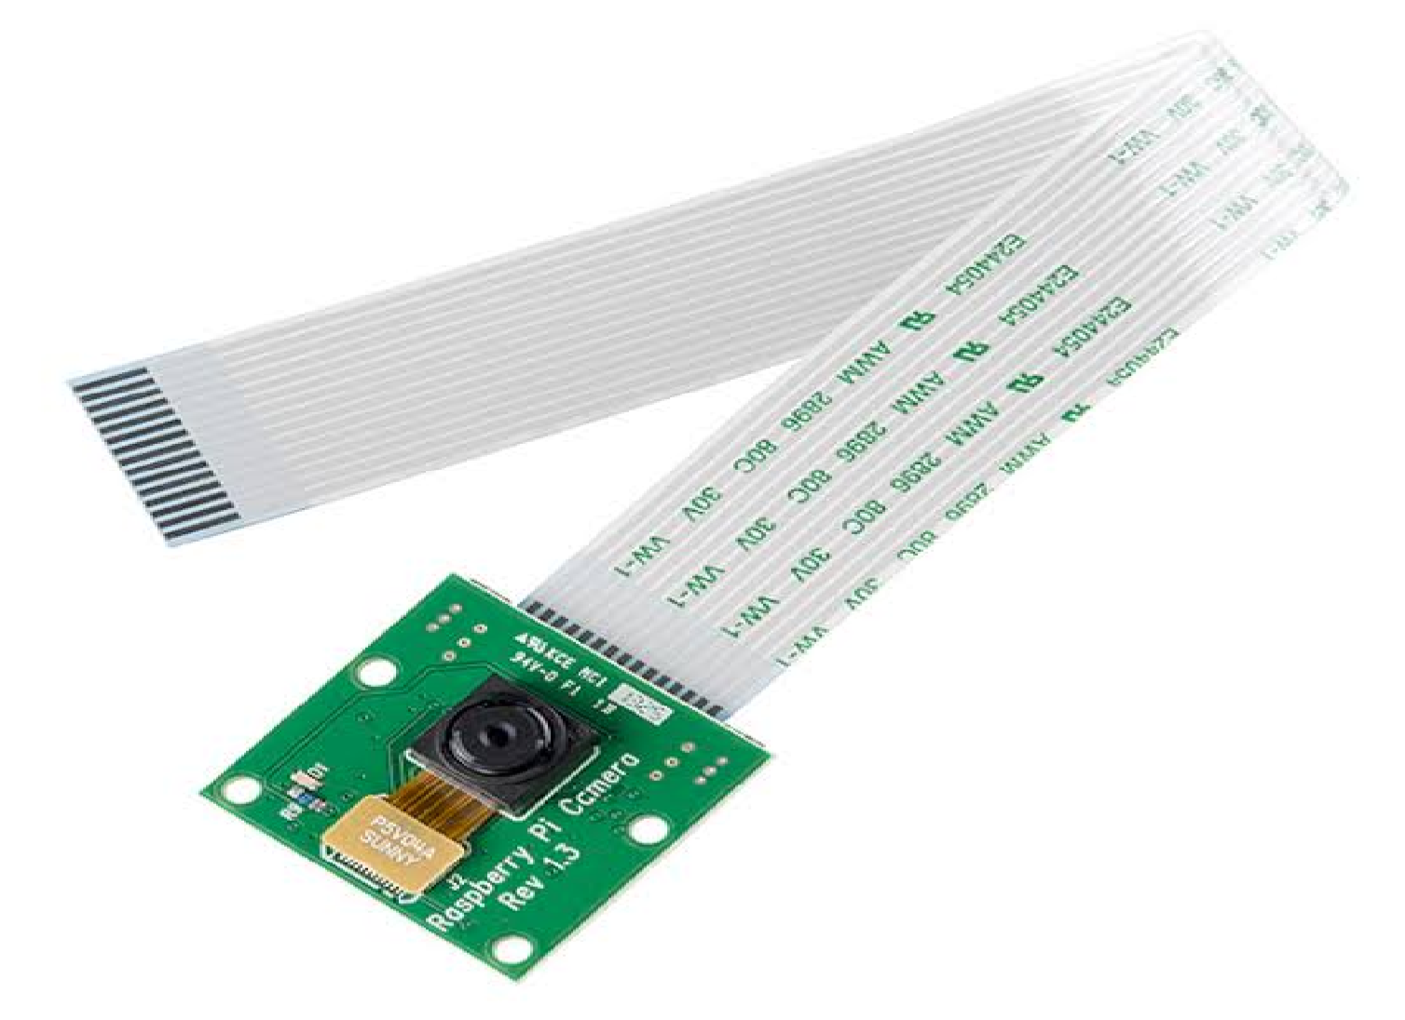

TheRaspberryPiCameraBoardplugsdirectlyintotheCSI connectorontheRaspberryPi.It'sabletodeliveracrystalclear 5MPresolutionimage,or1080pHDvideorecordingat30fps!

LatestVersion1.3!Customdesignedandmanufacturedbythe

RaspberryPiFoundationintheUK,theRaspberryPiCamera

Boardfeaturesa5MP(2592?1944pixels)Omnivision5647 sensorinafixedfocusmodule.Themoduleattachesto RaspberryPi,bywayofa15PinRibbonCable,tothededicated 15-pinMIPICameraSerialInterface(CSI),whichwasdesigned especiallyforinterfacingtocameras.TheCSIbusiscapableof extremelyhighdatarates,anditexclusivelycarriespixeldatato theBCM2835processor.Theboarditselfistiny,ataround 25mmx20mmx9mm,andweighsjustover3g,makingit perfectformobileorotherapplicationswheresizeandweight areimportant.Thesensoritselfhasanativeresolutionof5 megapixel,andhasafixedfocuslensonboard.Intermsofstill images,thecameraiscapableof2592x1944pixelstatic images,andalsosupports1080p@30fps,720p@60fpsand 640x480p60/90videorecording.Thecameraissupportedinthe latestversionofRaspbian,theRaspberryPi'spreferred operatingsystem.TheRaspberryPiCameraBoardFeatures:

FullyCompatiblewithBoththeModelAandModelBRaspberry

Pi

5MPOmnivision5647CameraModule

StillPictureResolution:2592x1944

Video:Supports1080p@30fps,720p@60fpsand640x480p 60/90Recording 15-pinMIPICameraSerialInterface-PlugsDirectlyintothe RaspberryPiBoard

Size:20x25x9mm

Weight3g

FullyCompatiblewithmanyRaspberryPicases

DownloadsDetailedCamera

5.3Monitordisplay

Acomputermonitorisanoutputdevicethatdisplaysinformationinpictorialortextform.A monitorusuallycomprisesavisualdisplay,somecircuitry,acasing,andapowersupply.The displaydeviceinmodernmonitorsistypicallyathinfilmtransistorliquidcrystaldisplay(TFTLCD)withLEDbacklightinghavingreplacedcold-cathodefluorescentlamp(CCFL)backlighting. Previousmonitorsusedacathoderaytube(CRT)andsomePlasma(alsocalledGas-Plasma) displays.MonitorsareconnectedtothecomputerviaVGA,DigitalVisualInterface(DVI),HDMI, DisplayPort,USB-C,low-voltagedifferentialsignaling(LVDS)orotherproprietaryconnectorsand signals

Originally,computermonitorswereusedfordataprocessing whiletelevisionsetswereusedforentertainment.Fromthe 1980sonwards,computers(andtheirmonitors)havebeenused forbothdataprocessingandentertainment,whiletelevisions haveimplementedsomecomputerfunctionality.Thecommon aspectratiooftelevisions,andcomputermonitors,haschanged from4:3to16:10,to16:9.

Moderncomputermonitorsareeasilyinterchangeablewith conventionaltelevisionsetsandviceversa.However,as computermonitorsdonotnecessarilyincludeintegrated speakersnorTVtuners(suchasdigitaltelevisionadapters),it maynotbepossibletouseacomputermonitorasaTVset withoutexternalcomponents.

Laptopdisplaysrangefromtheverysmall--the10-inch “netbook”computersdesignedprimarilyforsurfingtheInternet andbasicwordprocessing--tothesubstantial--17-inch-orgreaterscreensthatarethesizeofadesktopmonitor.Thereare advantagestobothsizes--andthesizesinbetween--butitall dependsonwhatyouneedthelaptopfor.Biggerscreensare handyforgraphics-editingsoftwareandvideowork,whereas smallerdisplaysmakeyourlaptoplighterandeasiertoplace intosmallerbags--aplusfortraveling.

5.4powersupply

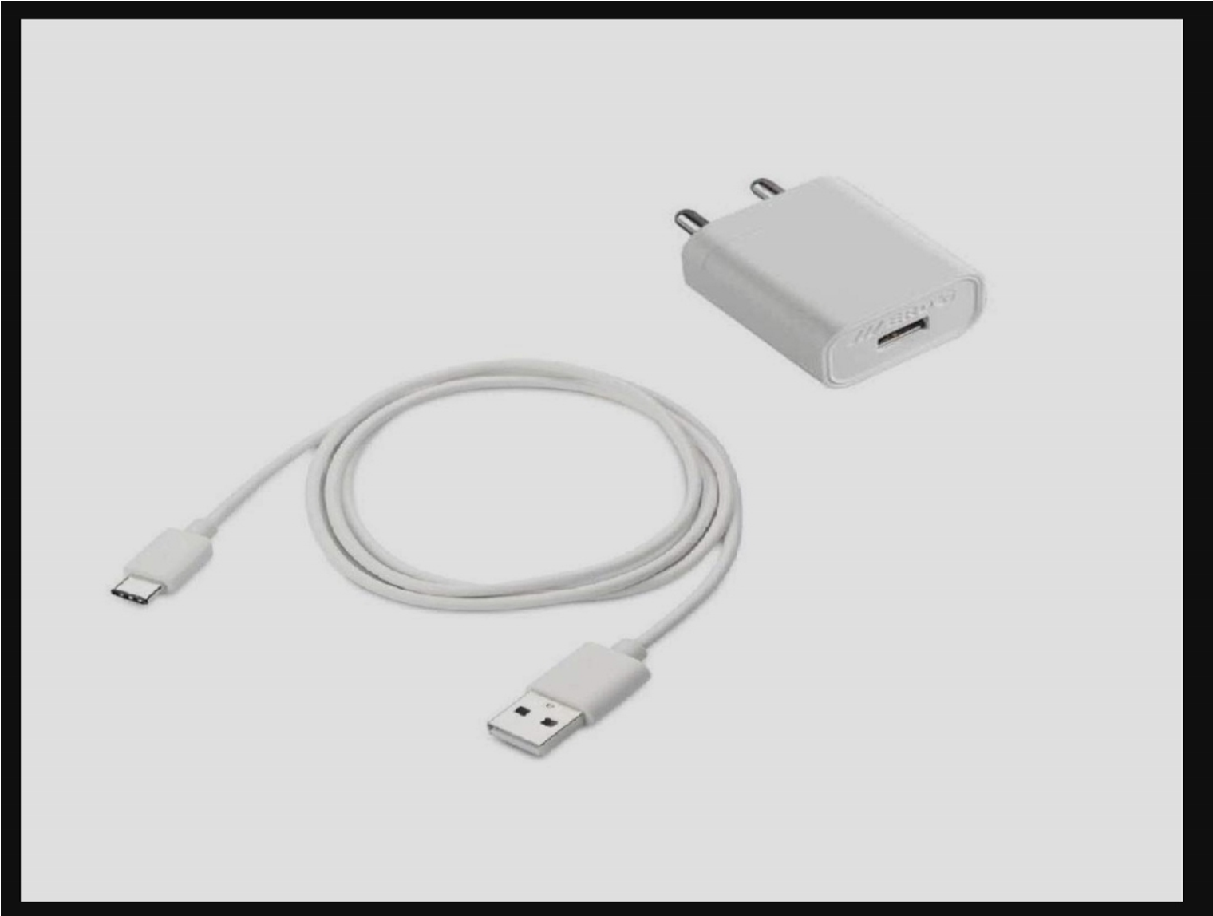

4.8PowerSupply(LM7805):

TheLM7805isavoltageregulatorthatoutputs+5volts.

Likemostotherregulatorsinthemarket,itisathree-pinIC;input pinforacceptingincomingDCvoltage,groundpinfor establishinggroundfortheregulator,andoutputpinthat suppliesthepositive5volts.

ProductFeatures:

3-TerminalRegulatorsOutputCurrentupto1.5A

InternalThermal-OverloadProtectionHighPower-Dissipation CapabilityInternalShort-CircuitCurrentLimiting

OutputTransistorSAFE-AreaCompensationAbsoluteMaximum

InputVoltage-35v

RecommendedOperatingConditions:

InputVoltage:Minimum7V,Maximum25VOutputCurrent:1.5A

OperatingVirtualJunctionTemperature:Minimum0,Maximum

125°C

Fig:4.8PowersupplPossibleHighTemperaturesIfdifferences betweentheinputandoutputvoltagesarenotwellmanaged, LM7805canoverheat,whichmayresultinmalfunctioning. SolutionsInclude:Limitinginputvoltageto2-3voltsabovethe outputregulatedvoltagePlacingaheatsinkinthecircuitto dissipateheatsolutions

LM7805ProductApplications:

LM7805isappliedinawiderangeofcircuitsFixed-Output

RegulatorPositiveRegulatorinNegativeConfiguration AdjustableOutputRegulatorCurrentRegulatorRegulatedDualSupplyOutputPolarity-Reversal-ProtectionCircuitReversebias projectionCircuitLM7805canalsobeusedinbuildingcircuits forinductancemeter,phonechargers,portableCDplayer,etc.

OPENCVWITHPYTHON

Introduction

Inthistutorial,wearegoingtolearnhowtouse OpenCV libraryinPython.OpenCVisan opensourcelibrarywhichissupportedbymultipleplatformsincludingWindows,Linux, andMacOS,andisavailableforuseinmultipleotherlanguagesaswell;however,itis mostcommonlyusedinPythonforMachineLearningapplications,specificallyinthe ComputerVisiondomain.

Apartfromitscross-platformsupportandavailabilityinmultipleothercomputer languages,whichallowsapplicationsdevelopedinittobeusedondifferentsystems, OpenCVisalso,incomparisontoothersuchlibraries,fairlyefficientintermsof computations,asitusesvectoroperationsformostofitsfunctions.

Inthistutorial,we'llcoverOpenCVinstallationonMac,Windows,andLinux,image operations,imagearithmetics,imagesmoothing,andgeometrictransformationsusing OpenCV.Sowithoutfurtherado,let'sstart.

Installation

Note:SincewearegoingtouseOpenCVinthePythonlanguage,itisanimplicit requirementthatyoualreadyhavePython(version3)installedonyourworkstation. DependinguponyourOS,executeoneofthefollowingcommandstoinstallOpenCV libraryonyoursystem:

Windows

$pipinstallopencv-python

MacOS

$brewinstallopencv3--with-contrib--with-python3 Linux

$sudoapt-getinstalllibopencv-devpython-opencv Tocheckifyourinstallationwassuccessfulornot,runthefollowingcommandineither aPythonshell,oryourcommandprompt/terminal:

importcv2

Ifyoudonotgetanerroronimporting cv2 thenitwasinstalledcorrectly.

BasicImageOperations

NowthatwehaveinstalledOpenCVonourworkstations,let'sgetourhandsdirtywith someofthefunctionalitiesthatOpenCVoffers.

DisplayanImage

DisplayinganimageusingOpenCVisatwo-stepprocess;first,wehavetoloadit,and thenwecandisplayit.Bothoperationsaredoneinsequenceusingdifferentfunctions.

Todisplayanimage,weneedtoknowtwothings:

1.ImagePath(bothabsoluteandrelativepathswork)

2.ReadMode(read,write,etc.)

Thefunctionwe'lluseforreading/loadinganimageis cv2.imread(),whichhastwo variations.Firstoneis IMREAD_GRAYSCALE,whichasthenamesuggests,convertsthe imagetograyscalebeforereadingit.Thesecondoneis IMREAD_UNCHANGED,which loadstheimagewithoutcuttingoutthealphachannel.Thedefaultis IMREAD_COLOR, whichsimplyreadsthecoloredimageusingtheRGBchannelsonly.

Let'scodeanexample:

importcv2

my_bike=cv2.imread('bike.png')

Thiswillloadtheimageofabikefrom thefilesystem andstoreitin

the my_bike variableforfurtheroperations

Note:Ifyougetanerrorfromtheabovecode,thereareonlythreepossiblereasonsfor it.Thefirstoneisthatthepathyouspecifiedisincorrect,secondisthattheimagefile youspecifieddoesn'texist,andthelastoneisthattheimagetype(jpg/jpeg/png)inthe imagepathisincorrect.

Let'snowdisplaytheimagewejustread.Itcanbedonebythe cv2.imshow() function.If youhaveusedMatlab,youmaybefamiliarwiththeseimageoperations.

cv2.imshow('my_bike',my_bike)

Thefirstparametertothe imshow() functionisthestringnamethatyouwanttodisplay ontheimagewindow.Thesecondparameteristheimagehandlerwecreatedusing the cv2.imread() function.

SavinganImage

Savinganimageisaverycommonlyusedfeature,aswemayneedtoupdateourimage andsavethechangestothefilesystem forlateruse.OpenCV has an cv2.imwrite() functiontosaveimages.

Hereisanexample:

cv2.imwrite('bike.png',my_bike)

Herewespecifythenameandcurrentlocationoftheimage.Theresultingimageis automaticallysavedinthecurrentworkingdirectory.

ArithmeticOperationsonImages

Arithmeticoperationsonimagesrefertoadding,subtracting,multiplying,ordividing multipleimagestogenerateanewimagewhichisanarithmeticcombinationofthe inputimages.Imagearithmeticshasalotofapplications,likeaddingawatermarktoan image,creatingablendedcombinationoftwoimages,applyingdifferenttypesofimage filters,etc.

Whiletherearemanyoperationsyoucanperform,wewillonlybeshowingtwo exampleshere,asthiswillthenallowyoutoapplytheconcepttootherarithmetic operationsavailableinOpenCV.Thefirstexamplewillbetheadditionoftwoimages, andthesecondexamplewillbeblendingtwoimages.

Let'scodethesetwoexamples:

AddingImages

importcv2

#Readinthetwoimages

image_1=cv2.imread('bike.jpg') image_2=cv2.imread('car.jpg')

#Sumthetwoimagearraysforallchannels result=cv2.add(image_1,image_2) cv2.imshow('result',result) cv2.waitKey(0) cv2.destroyAllWindows()

The waitKey commandwillwaitforyoutopressakeybeforeitmovesontothe nextcommand.Thisisusefulsothattheprogramwillcontinuetodisplayyour imageuntilakeyispressed,otherwiseitwillbedisplayedforasplitsecond andthenquicklydisappearoncetheprogramhasstoppedexecuting.

BlendingImages

Blendingimagesissimilartoimageaddition,excepteachimage's contributiontothenewresultingimagecanbecontrolled.Basically,ifwe wantoneimagetobemorefocused,andtheotheronetobemorefaintwhen theygetmerged,wewillgowithblending,insteadofsimpleaddition.

Letscodeittoclarifyfurther:

importcv2

#Readinthetwoimages

image_1=cv2.imread('bike.jpg') image_2=cv2.imread('car.jpg')

result=cv2.addWeighted(image_1,0.9,image_2,0.1)

cv2.imshow('result',result) cv2.waitKey(0)#Waitfortheusertopressakeybeforecontinuing cv2.destroyAllWindows()

Thesumoftheweightsgiventothe addWeighted functionshouldbeequalto1.0.You canalsogiveascalarvalueattheend,whichwouldbeaddedtoallthepixelvaluesof theresultantimage.

Note:Theimagescanbeofanytype;however,thetypeshouldbethesameforall images.Forinstance,ifyouareusingPNGformat,allimagesbeingusedfor computationshouldbeinPNGformataswell.

ImageSmoothing

Imagesmoothingisaveryhelpfulfeature,whichismostlyperformedbeforetheimages arepassedontoamachinelearningmodel.Itismostlydonetoremovenoise/highfrequencyelementsfromimagesbypassingtheimagethroughalow-passfilter.There aremanyfilters,includingboxfilter(averagingfilter),medianfilter,modefilter,Gaussian filter,andmanymore;however,tounderstandimagesmoothingandhowtodoitusing OpenCV,wewillonlycovertheboxfilter.

Let'ssayyouhaveanimageof10x10,andyouwanttopassitthrougha3x3 box/averagingfilter,howwouldyoudoit?

You'llstartwiththetopleftoftheimage,placeyour3x3filterthere,andreplacethe centralelementwiththeaverageofall9elements.Thiswasthefirststep,nowyouwill moveyourfilteronesteptotheright,andrepeatthesameprocessuntilyouhave coveredthewholeimage.Anexampleof10x10image,and3x3averagingfilterare shownbelowforyourreference:

Filter/Mask:

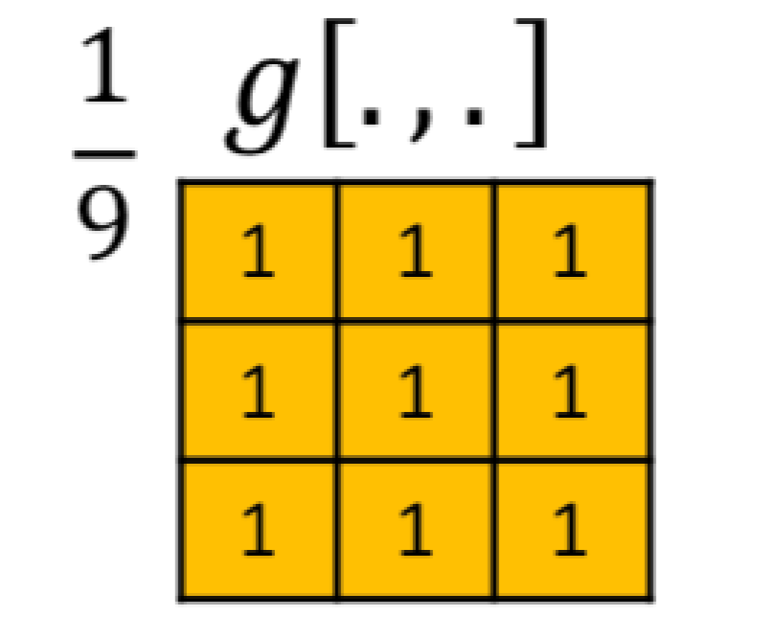

Filterbeingappliedon10x10Image:

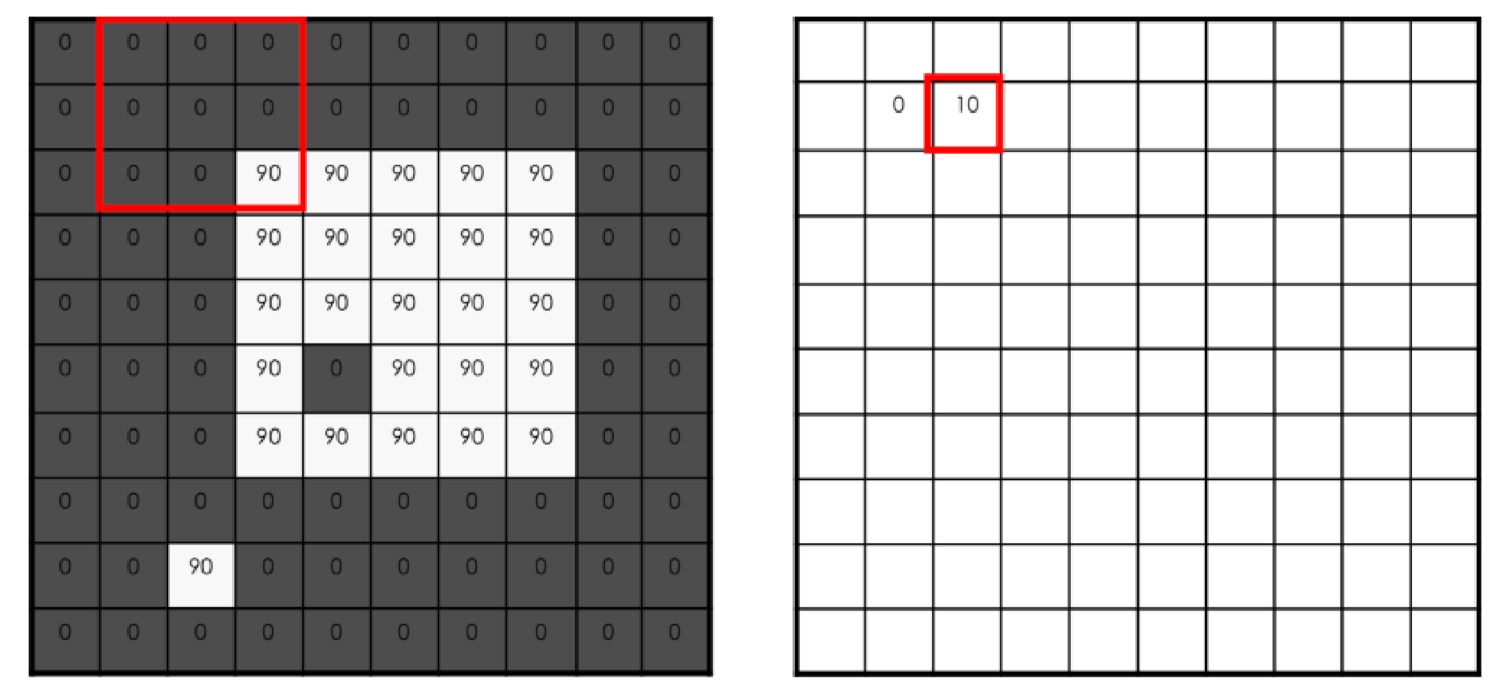

Nowthatwehavediscussedhowitworks,letstryandseehowwecanapplydifferent filtersonourimageusingOpenCV;pleasereadthecommentsthoroughlytoknow whichlineofcodeisusedforwhichfilter: importcv2

#Loadtheoriginalimage original_image=cv2.imread('my_bike.png')

#Filterbypassingimagethrough3x3averagingfilter average_image=cv2.blur(original_image,(3,3))

#Apply3x3gaussianfilterontheoriginalimage gaussian_image=cv2.GaussianBlur((original_image,(3,3),0))

#Apply3x3medianfilterontheoriginalimage median_image=cv2.medianBlur(original_image,3)

Note:Youcanviewtheresultingimagesbyusingthefollowingadditionalcode:

importmatplotlib.pyplotasplt

plt.imshow(average_image) plt.show()

ImageTransformations

Imagetransformationisthelast,butoneofthemostimportanttopicsthatwearegoing tocoverwithOpenCV.Ithasalotofapplications,butoneofthemostcommonones nowadaysisinMachineLearningforDataAugmentation,i.e.whenyouhaveashortage ofdataset,youaugment/transformthecurrentlyavailableimagestomakethem differentfromyourexistingdataset.Thiseffectivelyincreasesyourdatasetsizeand mighthelpinimprovingyourmodelaccuracy.

Thelistofpossibletransformationsisalongone,includingscaling, affine,rotation, translation,etc.WewillonlycovertwoofthemusingOpenCVtogetageneralidea; however,OpenCVprovidessupportingfunctionsforawiderangeofthem.Let'sstart withscaling.

Scaling

Toputitinsimplewords,scalingisbasicallyjustresizingyourimage,i.e.eithermaking itbiggerorsmaller. resize isthefunctionusedforscalingtheimagesinOpenCV. Resizinghasthreetypes: INTER_CUBIC, INTER_LINEAR,and INTER_AREA.Let'scodean exampleusingthesefunctionsforscaling;pleasereadthroughthecode,comments, anddescriptionscarefullyastheywillexplainwhatexactlyisgoingoninthecode:

importcv2 importnumpyasnp

importmatplotlib.pyplotasplt

image=cv2.imread('my_bike.jpg')

#Scaleup/expandbothwidthandheightbyfactorof2 result_1=cv2.resize(image,None,fx=2,fy=2,interpolation=cv2.INTER_CUBIC)

#Scaledown/shrinkbothwidthandheightbyfactorof2 result_2=cv2.resize(image,None,fx=2,fy=2,interpolation=cv2.INTER_AREA)

#Displaytheresultingimages plt.imshow(result_1) plt.imshow(result_2) plt.show()

Hereinthe resize function,the fx parameterinrepresentsthescalefactorfor width, fy representsthescalefactorheight,and interpolation specifiesthefunctionto beusedforscaling(shrinkingorexpansion).

Rotation

Rotationallowsustomoveanimageabouttheaxisforacertainspecifiedangle.

Beforewelearnhowtorotateourimagesusingcode,weshouldknowthatthereis a rotationmatrix thatisusedforperformingthistransformation;wewillnotgoin detailsofthat,asOpenCVmakesitverysimpleforustocalculatethatmatrixusinga singlefunctioncall.Youwillseethatinthecodebelow:

importcv2 importmatplotlib.pyplotasplt

#Loadtheimageofabike

image=cv2.imread('my_bike.jpg',0)

#Rowsandcolumns r,c=image.shape

matrix=cv2.getRotationMatrix2D((cols/2,rows/2),180,1) result=cv2.warpAffine(image,matrix,(c,r))

#Displayresultingrotation plt.imshow(result) plt.show()

Inthe getRotationMatrix2D function,180specifiesthedegreebywhichtheimage shouldberotated,1isthescalingfactor,thefunctioncallwouldreturntherotation matrixinthe matrix variable.

The warpAffine functioncallusesthematrixwecalculatedfromthepreviousmethodto rotatetheimageaccordingtoourspecifications.

CHAPTER-5

ANINTRODUCTIONTOCONVOLUTIONALNEURALNETWORKS

AConvolutionalneuralnetwork(CNN)isaneuralnetworkthathasoneormore convolutionallayersandareusedmainlyforimageprocessing,classification, segmentationandalsoforotherautocorrelateddata.

Aconvolutionisessentiallyslidingafilterovertheinput.Onehelpfulwaytothinkabout convolutionsisthisquotefromDrPrasadSamarakoon:“Aconvolutioncanbethought as“lookingatafunction’ssurroundingstomakebetter/accuratepredictionsofits outcome.”

Ratherthanlookingatanentireimageatoncetofindcertainfeaturesitcanbemore effectivetolookatsmallerportionsoftheimage.

CommonusesforCNNs

ThemostcommonuseforCNNsisimageclassification,forexampleidentifyingsatellite imagesthatcontainroadsorclassifyinghandwrittenlettersanddigits.Thereareother quitemainstreamtaskssuchasimagesegmentationandsignalprocessing,forwhich CNNsperformwellat.

CNNshavebeenusedforunderstandinginNaturalLanguageProcessing(NLP)and speechrecognition,althoughoftenforNLPRecurrentNeuralNets(RNNs)areused.

ACNNcanalsobeimplementedasaU-Netarchitecture,whichareessentiallytwo almostmirroredCNNsresultinginaCNNwhosearchitecturecanbepresentedinaU shape.U-netsareusedwheretheoutputneedstobeofsimilarsizetotheinputsuchas segmentationandimageimprovement.

InterestingusesforCNNsotherthanimageprocessing

MoreandmorediverseandinterestingusesarebeingfoundforCNNarchitectures.An exampleofanon-imagebasedapplicationis “TheUnreasonableEffectivenessof ConvolutionalNeuralNetworksinPopulationGeneticInference” byLexFlageletal.This isusedtoperformselectivesweeps,findinggeneflow,inferringpopulationsizechanges, inferringrateofrecombination.

ThereareresearcherssuchasProfessorGeraldQuonatthe Quon-titativebiologylab, usingCNNsforgenerativemodelsinsinglecellgenomicsfordiseaseidentification.

CNNsarealsobeingusedinastrophysicstointerpretradiotelescopedatatopredictthe likelyvisualimagetorepresentthedata.

Deepmind’sWaveNet isaCNNmodelforgeneratingsynthesizedvoice,usedasthe basisforGoogle’sAssistant’svoicesynthesizer.

Convolutionalkernels

Eachconvolutionallayercontainsaseriesoffiltersknownasconvolutionalkernels.The filterisamatrixofintegersthatareusedonasubsetoftheinputpixelvalues,thesame sizeasthekernel.Eachpixelismultipliedbythecorrespondingvalueinthekernel,then theresultissummedupforasinglevalueforsimplicityrepresentingagridcell,likea pixel,intheoutputchannel/featuremap.

Thesearelineartransformations,eachconvolutionisatypeofaffinefunction.

Incomputervisiontheinputisoftena3channelRGBimage.Forsimplicity,ifwetakea greyscaleimagethathasonechannel(atwodimensionalmatrix)anda3x3 convolutionalkernel(atwodimensionalmatrix).Thekernelstridesovertheinputmatrix ofnumbersmovinghorizontallycolumnbycolumn,sliding/scanningoverthefirstrows inthematrixcontainingtheimagespixelvalues.Thenthekernelstridesdownvertically tosubsequentrows.Note,thefiltermaystrideoveroneorseveralpixelsatatime,thisis detailedfurtherbelow.

Inothernon-visionapplications,aonedimensionalconvolutionmayslideverticallyover aninputmatrix.

Creatingafeaturemapfromaconvolutionalkernel

Belowisadiagramshowingtheoperationoftheconvolutionalkernel.

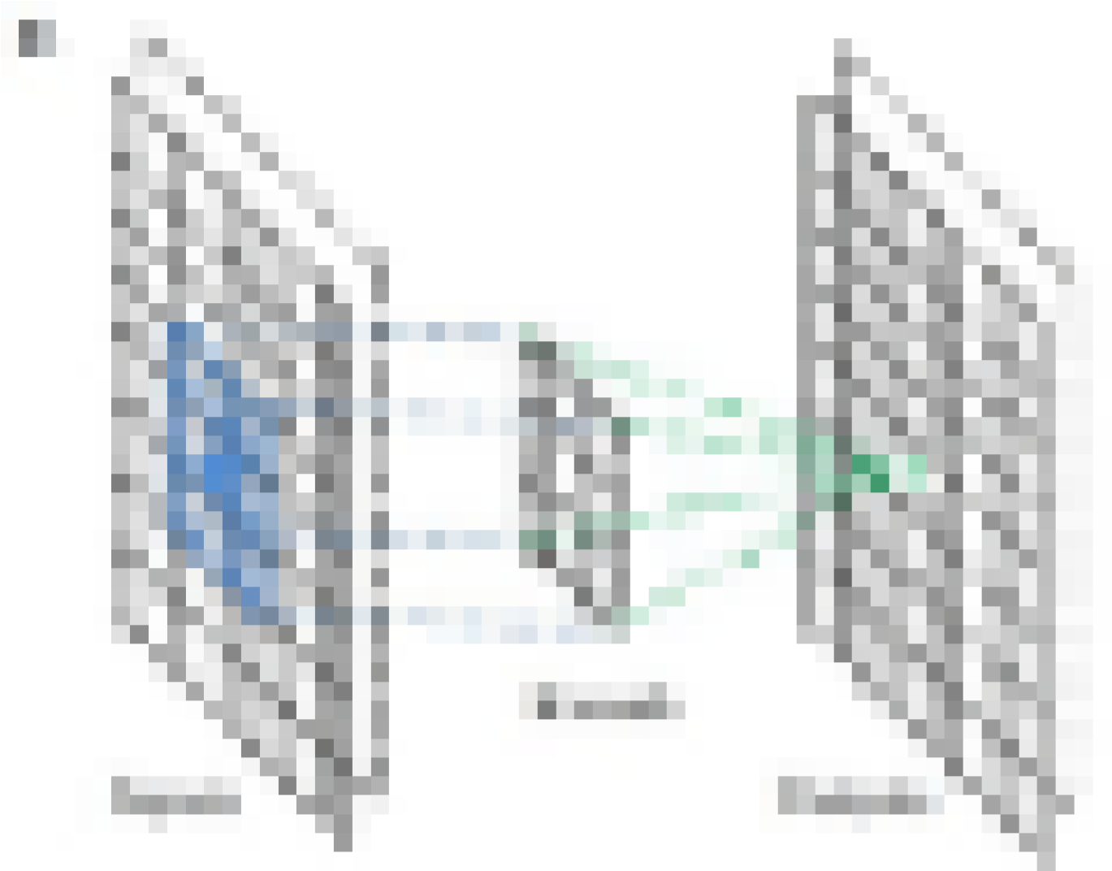

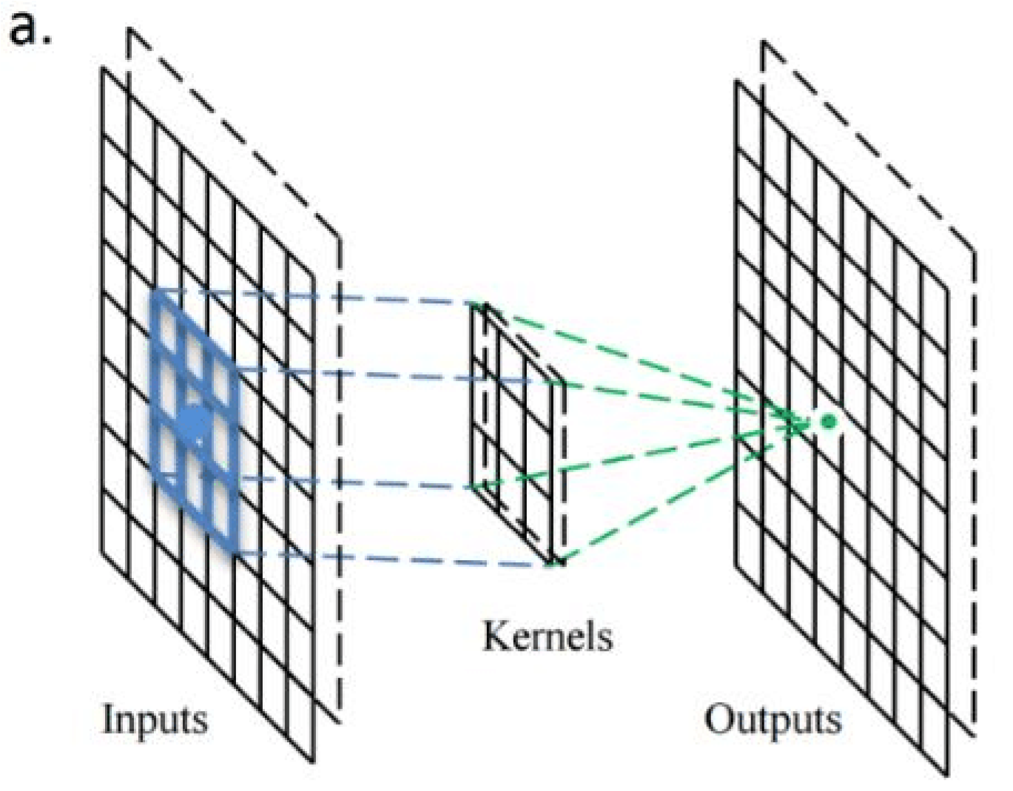

Astrideone3x3convolutionalkernelactingona8x8inputimage,outputtingan8x8 filter/channel. Source: https://www.researchgate.net/figure/a-Illustration-of-theoperation-principle-of-the-convolution-kernel-convolutional-layer_fig2_309487032

Belowisavisualisationfromanexcellentpresentation,showingthekernelscanning overthevaluesintheinputmatrix.

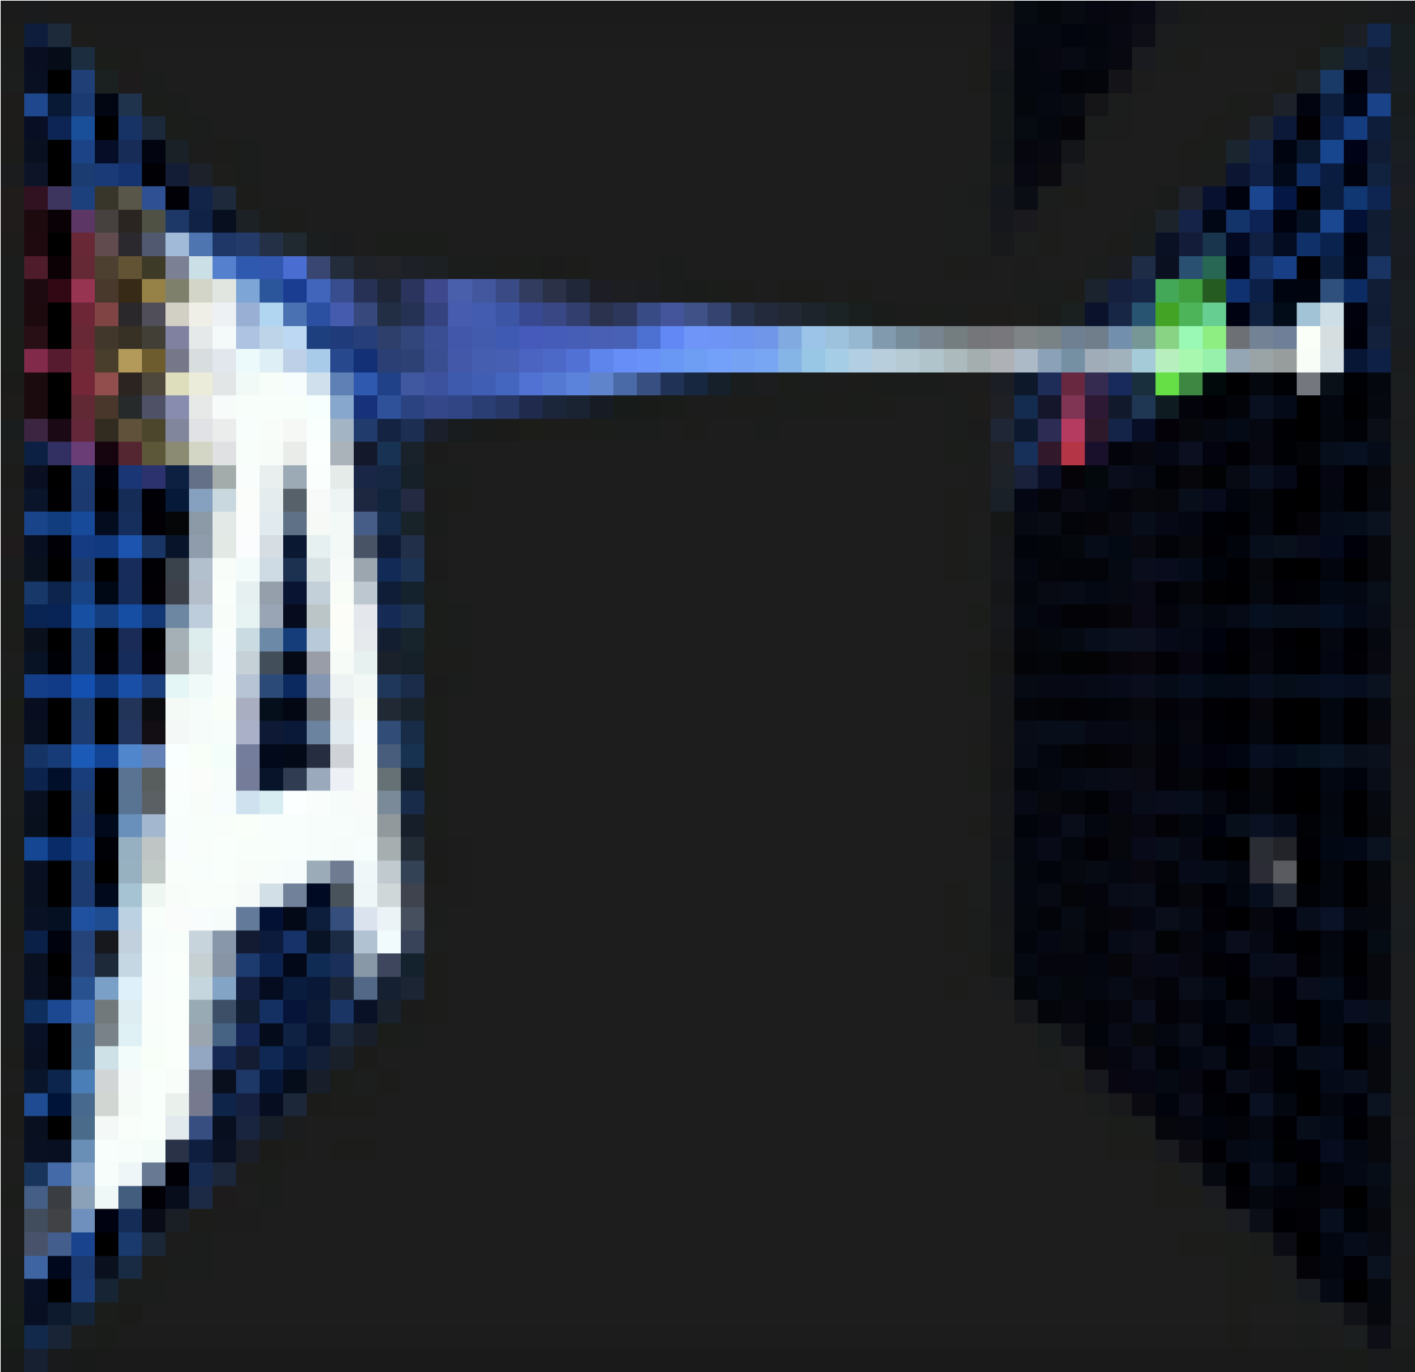

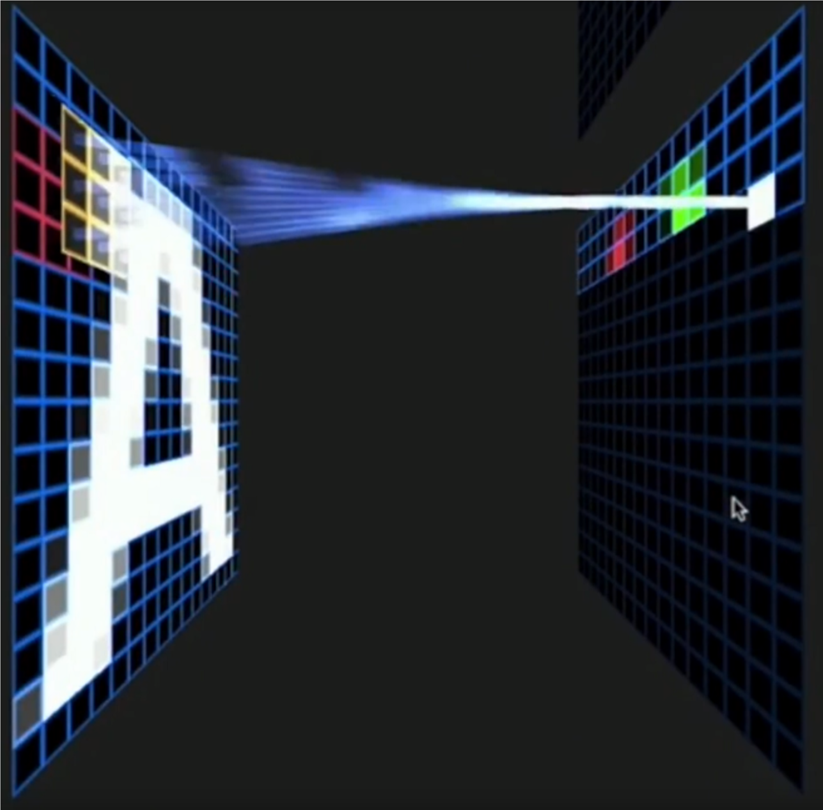

Kernelscanningoverthevaluesintheinputmatrix.Source:OtavioGood: excerpt https://www.youtube.com/watch?v=f0t-OCG79U from https://www.youtube.com/watch?v=Oqm9vsf_hvU

Padding

Tohandletheedgepixelsthereareseveralapproaches:

* Losingtheedgepixels
* Paddingwithzerovaluepixels
* Reflectionpadding

Reflectionpaddingisbyfarthebestapproach,wherethenumberofpixelsneededfor theconvolutionalkerneltoprocesstheedgepixelsareaddedontotheoutsidecopying thepixelsfromtheedgeoftheimage.Fora3x3kernel,onepixelneedstobeadded aroundtheoutside,fora7x7kernelthenthreepixelswouldbereflectedaroundthe outside.Thepixelsaddedaroundeachsideisthedimension,halvedandroundeddown.

Traditionallyinmanyresearchpapers,theedgepixelsarejustignored,whichlosesa smallproportionofthedataandthisgetsincreasingworseiftherearemanydeep convolutionallayers.Forthisreason,Icouldnotfindexistingdiagramstoeasilyconvey someofthepointsherewithoutbeingmisleadingandconfusingstride1convolutions withstride2convolutions.

Withpadding,theoutputfromainputofwidthwandheighthwouldbewidthwand heighth(thesameastheinputwithasingleinputchannel),assumingthekerneltakesa strideofonepixelatatime.

Creatingmultiplechannels/featuremapswithmultiplekernels

Whenmultipleconvolutionalkernelsareappliedwithinaconvolutionallayer,many channels/featuremapsarecreated,onefromeachconvolutionalkernel.Belowisa visualisationbelowshowingthechannels/featuremapsbeingcreated. ee

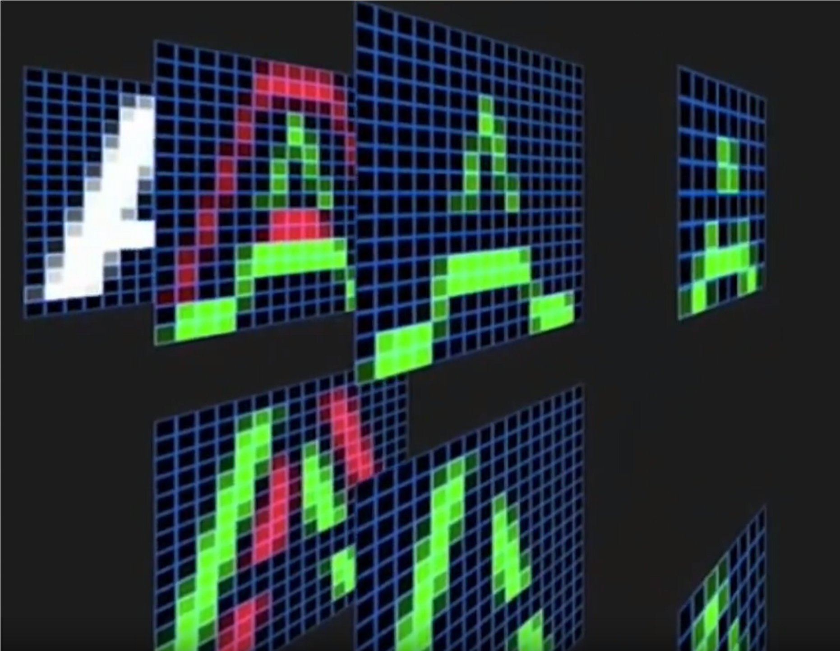

Visualisationofchannels/featuremapscreatedfromalayerofconvolutionalkernels.

Source: Otavio Good: excerpt https://www.youtube.com/watch?v=f0t-OCG79U from https://www.youtube.com/watch?v=Oqm9vsf_hvU

RGB3channelinput

MostimageprocessingneedstooperateonRGBimageswiththreechannels.ARGB imageisathreedimensionalarrayofnumbersotherwiseknownasarankthreetensor.

WhenprocessingathreechannelRGBimage,aconvolutionalkernelthatisathree dimensionalarray/rank3tensorofnumberswouldnormallybeused.Itisverycommon fortheconvolutionalkerneltobeofsize3x3x3— theconvolutionalkernelbeinglikea cube.

Usuallythereisatleastthreeconvolutionalkernelsinorderthateachcanactasa differentfiltertogaininsightfromeachcolourchannel.

Theconvolutionkernelsasagroupmakeafourdimensionalarray,otherwiseknownasa rankfourtensor.Itisdifficult,ifnotimpossible,tovisualisedimensionswhentheyare higherthanthree.Inthiscaseimagineitasalistofthreedimensionalcubes.

Thefiltermovesacrosstheinputdatainthesameway,slidingortakingstridesacross therowsthenmovingdownthecolumnsandstridingacrosstherowsuntilitreachesthe bottomrightcorner:

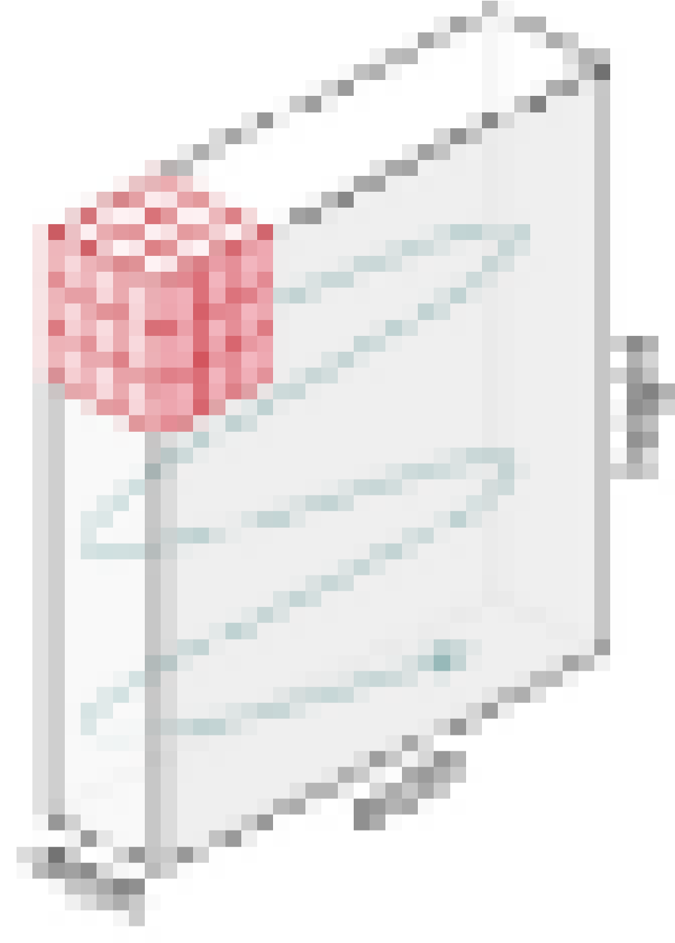

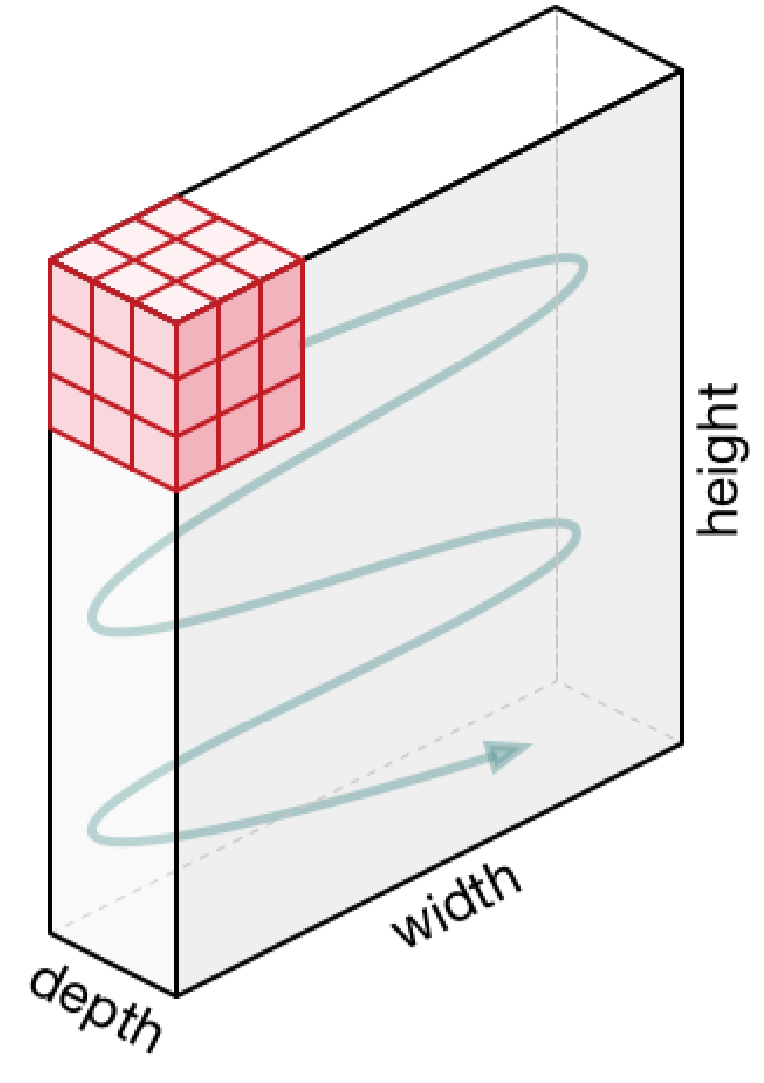

3x3x3 convolutional kernel acting on a 3 channel input.

Source: https://machinethink.net/images/vggnet-convolutional-neural-networkiphone/ConvolutionKernel@2x.png

Withpaddingandastrideofone,theoutputfromaninputofwidthx,heightyanddepth 3wouldbewidthx,heightyanddepth1,asthecubeproducesasinglesummedoutput valuefromeachstride.Forexample,withaninputof3x64x64(saya64x64RGBthree channelimage)thenonekerneltakingstridesofonewithpaddingtheedgepixelswould outputachannel/featuremapof64x64(onechannel).

Itisworthnotingtheinputisoftennormalised,thisisdetailedfurtherbelow.

Strides

Itiscommontouseastridetwoconvolutionratherthanastrideoneconvolution,where theconvolutionalkernelstridesover2pixelsatatime,forexampleour3x3kernelwould startatposition(1,1),thenstrideto(1,3),thento1,5)andsoon,halvingthesizeofthe outputchannel/featuremap,comparedtotheconvolutionalkerneltakingstridesofone.

Withpadding,theoutputfromaninputofwidthw,heighthanddepth3wouldbethe ceilingofwidthw/2,heighth/2anddepth1,asthekerneloutputsasinglesummed outputfromeachstride.

Forexample,withaninputof3x64x64(saya64x64RGBthreechannelimage),one kerneltakingstridesoftwowithpaddingtheedgepixels,wouldproducea channel/featuremapof32x32.

Manykernels

InCNNmodelsthereareoftentherearemanymorethanthreeconvolutionalkernels,16 kernelsoreven64kernelsinaconvolutionallayeriscommon.

Thesedifferentconvolutionkernelseachactasadifferentfiltercreatinga channel/featuremaprepresentingsomethingdifferent.Forexample,kernelscouldbe filteringtopedges,bottomedges,diagonallinesandsoon.Inmuchdeepernetworks thesekernelscouldbefilteringtoanimalfeaturessuchaseyesorbirdwings.

Havingahighernumberofconvolutionalkernelscreatesahighernumberof channels/featuremapsandagrowingamountofdataandthisusesmorememory.The stride2convolution,aspertheaboveexample,helpstoreducethememoryusageas theoutputchannelofthestride2convolutionhashalfthewidthandheightoftheinput. Thisassumesreflectionpaddingisbeingusedotherwiseitcouldbeslightlysmaller.

Anexampleofseveralconvolutionallayersofstride2

Witha64pixelsquareinputwiththreechannelsand163x3x3kernelsourconvolutional layerwouldhave:

Input:64x64x3

Convolutionalkernels:16x3x3x3(afourdimensionaltensor)

Output/activationsoftheconvolutionalkernels:16x32x32(16channels/featuremapsof 32x32)

Thenetworkcouldthenapplybatchnormalisationtodecreaselearningtimeandreduce overfitting,moredetailsbelow.Inadditionanon-linearactivationfunction,suchasRELU isusuallyappliedtoallowthenetworktoapproximatebetter,moredetailsbelow.

Oftenthereareseverallayersofstride2convolutions,creatinganincreasingnumberof channels/featuremaps.Takingtheexampleabovealayerdeeper:

Input:16x32x32

Convolutionalkernels:64x3x3x3

Output/activationsoftheconvolutionalkernels:64x16x16(64channels/featuremapsof 16x16)

ThenafterapplyingReLUandbatchnormalisation(seebelow),anotherstride2 convolutionisapplied:

Input:64x16x16

Convolutionalkernels:128x3x3x3

Output/activationsoftheconvolutionalkernels:128x8x8(128channels/featuremapsof 8x8).

Classification

If,forexample,animagebelongstooneof42categoriesandthenetwork’sgoalisto predictwhichcategorytheimagebelongsto.

Followingonfromtheaboveexamplewithanoutputof128x8x8,firsttheaveragepool oftherank3tensoristaken.Theaveragepoolisthemeanaverageofeachchannel,in thethisexampleeach8x8matrixisaveragedintoasinglenumber,with128 channels/featuremaps.Thiscreates128numbers,avectorofsize1x128.

Thenextlayerisamatrixorrank2tensorof128x42weights.Theinput1x128matrixis (dotproduct)multipliedbythe128x42matrixproducinga1x42vector.Howactivated eachofthe42gridcells/vectorelementsare,ishowmuchthepredictionmatchesthat classificationrepresentedbythatvectorelement.Softmaxisappliedasanactivation functionandthenargmaxtoselecttheelementhighestvalue.

RectifiedLinearUnit(ReLU)

ARectifiedLinearUnitisusedasanon-linearactivationfunction.AReLUsaysifthe valueislessthanzero,roundituptozero.

Normalisation

Normalisationistheprocessofsubtractingthemeananddividingbythestandard deviation.Ittransformstherangeofthedatatobebetween-1and1makingthedata usethesamescale,sometimescalledMin-Maxscaling.

Itiscommontonormalizetheinputfeatures,standardisingthedatabyremovingthe meanandscalingtounitvariance.Itisoftenimportanttheinputfeaturesarecentred aroundzeroandhavevarianceinthesameorder.

Withsomedata,suchasimagesthedataisscaledsothatit’srangeisbetween0and1, mostsimplydividingthepixelvaluesby255.

Thisalsoallowsthetrainingprocesstofindtheoptimalparametersquicker.

Batchnormalisation

Batchnormalisationhasthebenefitsofhelpingtomakeanetworkoutputmorestable predictions,reduceoverfittingthroughregularisationandspeedsuptrainingbyanorder ofmagnitude.

Batchnormalisationistheprocessofcarryingnormalisationwithinthescopeactivation layerofthecurrentbatch,subtractingthemeanofthebatch’sactivationsanddividingby thestandarddeviationofthebatchesactivations.

Thisisnecessaryasevenafternormalizingtheinputassomeactivationscanbehigher, whichcancausethesubsequentlayerstoactabnormallyandmakesthenetworkless stable.

Asbatchnormalisationhasscaledandshiftedtheactivationoutputs,theweightsinthe nextlayerwillnolongerbeoptimal.Stochasticgradientdescent(SGD)wouldundothe normalisation,asitwouldminimisethelossfunction.

TopreventthiseffecttwotrainableparameterscanbeaddedtoeachlayertoallowSGD todenormalisetheoutput.Theseparametersareameanparameter“beta”anda standarddeviationparameter“gamma”.Batchnormalisationsetsthesetwoweightsfor eachactivationoutputtoallowthenormalisationtobereversedtogettherawinput,this avoidsaffectingthestabilityofthenetworkbyavoidinghavingtoupdatetheother weights.

WhyCNNsaresopowerful

InsimpletermsalargeenoughCNNcansolveanysolvableproblem.

NotableCNNarchitecture’sthatperformexceptionallywellacrossmanydifferentimage processingtasksaretheVGGmodels(K.SimonyanandA.Zisserman),theResNet models(KaimingHeetal)andtheGoogleInceptionmodels(ChristianSzegedyetal).

Thesemodelshavemillionsoftrainableparameters.

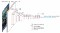

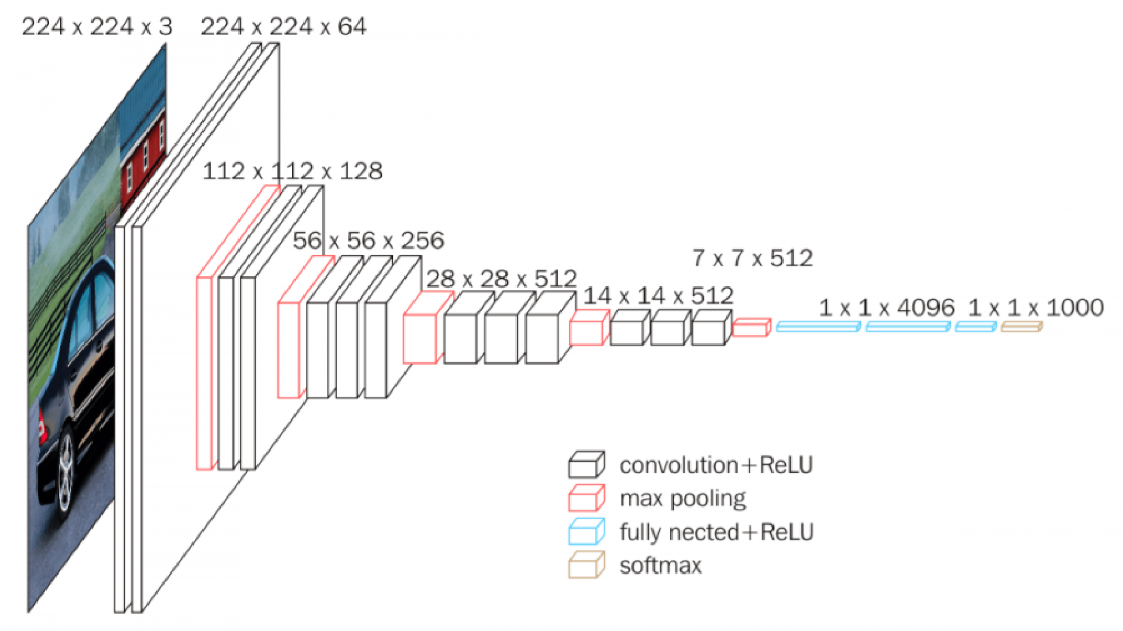

VGG-16 Network Architecture. Source: https://neurohive.io/wp-

content/uploads/2018/11/vgg16-1-e1542731207177.png

Universalapproximationtheorem

TheUniversalapproximationtheoremessentiallystatesifaproblemcanbesolveditcan besolvedbydeepneuralnetworks,givenenoughlayersofaffinefunctionslayeredwith non-linearfunctions.Essentiallyastackoflinearfunctionsfollowedbynon-linear functionscouldsolveanyproblemthatissolvable.

Practicallyinimplementationthiscanbemanymatrixmultiplicationwithlargeenough matricesfollowedbyRELU,stackedtogetherthesehaveamathematicalproperty resultinginbeingabletosolveanyarbitrarycomplexmathematicalfunctiontoany arbitraryhighlevelofaccuracyassumingyouhavethetimeandresourcetotrainit.

Whetherthiswouldgivetheneuralnetworkunderstandingisadebatedtopic,especially bycognitivescientists.Theargumentisthatnomatterhowwellyouapproximatethe syntaxandsemanticsofaproblem,youneverunderstandit.Thisisbasicallythe foundationofSearle’sChineseRoomArgument.Somewouldarguethatdoesitmatterif youcanapproximatethesolutiontotheproblemwellenoughthatit’sindistinguishable fromunderstandingtheproblem.

CHAPTER-6

RESULTANALYSYS

Forthedetection,leavesofdiseasesareselected.Thedatabaseofhealthy leavesanddiseasedleavesiscreatedattheserver.Thisisnecessarytocompare theimageswithdiseasedandhealthyleaves.Hencebycomparison,thedisease typeisclassified.Figure6,figure7,figure8showstheoutputscreenshotsof proposedsystem.

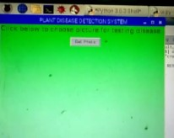 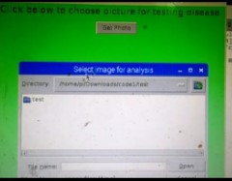

Fig6Accesingimage

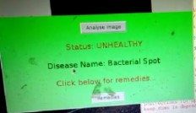 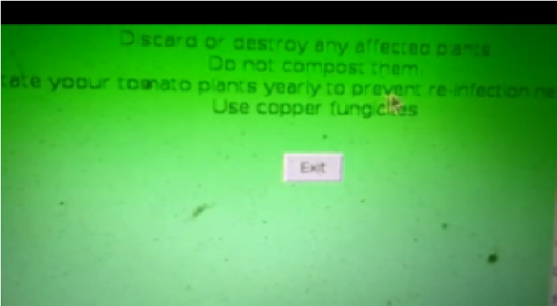

Fig7.Displayingdiseasedetails Fig8.DisplayingSolutions

CHAPTER-7

CONCLUSION

BasicallytherearethreemaintypesofLeafdisease,theyareBacterial,Fungal andViral.Itisimportantinplantdiseasedetectiontohavetheaccuracyintheplant diseasedetectionbutatthesametimetheprocessshouldbeofhighspeed.Work canbeextendedbytheuseofquadcopterforthecapturingofimagesofleavesof thedifferentplantsinthefarmatfieldlevel.Thissystemcanbeconnectedtothe serverforfurtherprocessing.Theobjectiveofthisworkisthedetection, classificationofleafdiseasesusingimageprocessingtoolsandallinformation aboutthediseaseissenttothefarmer’smobilephonethroughtheinternet.To increasethespeedandaccuracyofdetectionaswellasclassificationofleaf diseasesweusingRaspberrypi3modelBmodule.Onemoreimportantbenefitof thissystemisthatitgivesthenameofthepesticiderequiredtouseinorderto preventthediseaseformspreading.Itprovidingexactnameofpesticideasperthe disease,tosavelaborpricebyeliminatingneedoflaborforregularobservationof plantstocheckwhetheritisaffectedbyanydiseaseornot.Thissystemwilllargely contributeingrowthintheyieldofthefarms.

REFERENCES

[1]SachinD.Khirade,A.BPatil,“PlantDiseaseDetectionUsingImage Processing”,InternationalConferenceonComputingCommunicationControland Automation”,2015.

[2]Prof.SanjayB.Dhaygude,Mr.NitinP.Kumbhar,“AgriculturalplantLeaf

DiseaseDetectionUsingImageProcessing”,InternationalJournalofAdvanced ResearchinElectrical,ElectronicsandInstrumentationEngineeringVol.2,Issue1, January2013.

[3]AmandeepSingh,ManinderLalSingh,“AutomatedColorPredictionofPaddy CropLeafusingImageProcessing”,InternationalConferenceonTechnological InnovationsinICTforAgricultureandRuralDevelopment(TIAR2015),2015.

[4]M.Malathi,K.Aruli,S.MohamedNizar,A.SagayaSelvaraj,“ASurveyonPlant LeafDiseaseDetectionUsingImageProcessingTechniques”,InternationalResearch JournalofEngineeringandTechnology(IRJET),Volume:02Issue:09,Dec2015.

[5]MalvikaRanjan,ManasiRajivWeginwar,NehaJoshi,Prof.A.B.Ingole, “detectionandclassificationofleafdiseaseusingartificialneuralnetwork”, InternationalJournalofTechnicalResearchandApplications,2015.

[6]Y.Sanjana,AshwathSivasamy,SriJayanth,“PlantDiseaseDetectionUsing ImageProcessingTechniques”,InternationalJournalofInnovativeResearchin Science,EngineeringandTechnology,Vol.4,SpecialIssue6,May2015.

[7]BhumikaS.Prajapati,VipulK.DabhiHarshadkumar,B.Prajapati,“ASurveyon DetectionandClassificationofCottonLeafDiseases”,InternationalConferenceon Electrical,Electronics,andOptimizationTechniques(ICEEOT)–2016.

[8]P.Revathi,M.Hemalatha,“AdvanceComputingEnrichmentEvaluationof CottonLeafSpotDiseaseDetectionUsingImageEdgedetection”,ICCCNT'12.

[9]Mr.PramodS.landge,SushilA.Patil,DhanashreeS.Khot,“Automatic

DetectionandClassificationofPlantDiseasethroughImageProcessing”, InternationalJournalofAdvancedResearchinComputerScienceandSoftware Engineering,Volume3,Issue7,2013.

[10]HeebAlBashish,MalikBraik,andSuliemanBani-Ahmad,“AFrameworkfor

DetectionandClassificationofPlantLeafandStemDiseases”,IEEE2010

[11]M.Reyalat,AlHiary,BaniAhmad,BraikandZ.Rahamneh,“FastandAccurate DetectionandClassificationofPlantDiseases”.

[12]SmithJS.,CamargoA.,“Animageprocessingbasedalgorithmtoautomatically identifyplantdiseasevisualsymptoms”.

[13]Sulaiman,N.,Mustapha,“K-meansclusteringtoimprovetheaccuracy”.

[14]DavidMount,Tapaskanungo,“AnEfficientkmeansClusteringAlgorithm: AnalysisandImplementation”.

[15]FordA.,Robert,“ColourSpaceConversions”,.

[16]CMProcopiuc,P.K.Agarwal,“ExactandApproximationAlgorithmsfor Clustering”.

[17]DevendraP.Marathe,V.A.Patil,V.D.Chaudhari,“Reliablemassagetransferto alternatewaysi.e.Wi-Fi,Bluetooth,ZigBee,Internet,GPRS/GSMofcommunication Media”,IJET,vol5,issue7.Pp2015

[18]JiangLu,JieHu,GuannanZhao,FenghuaMei,ChangshuiZhang,Anin-field automaticwheatdiseasediagnosissystem,ComputersandElectronicsinAgriculture 142(2017)369–379.

[19]AndreasKamilaris,FrancescX.Prenafeta-BolduDeeplearninginagriculture:A survey,ComputersandElectronicsinAgriculture147(2018)70–90.

import tkinter as tk

from tkinter.filedialog import askopenfilename

import shutil

import os

import sys

import PIL

from PIL import Image, ImageTk

window = tk.Tk()

window.title("Dr. Plant")

window.geometry("500x510")

window.configure(background ="lightgreen")

title = tk.Label(text="Click below to choose picture for testing disease....", background = "lightgreen", fg="Brown", font=("", 15))

title.grid()

def bact():

window.destroy()

window1 = tk.Tk()

window1.title("Dr. Plant")

window1.geometry("500x510")

window1.configure(background="lightgreen")

def exit():

window1.destroy()

rem = "The remedies for Bacterial Spot are:\n\n "

remedies = tk.Label(text=rem, background="lightgreen",

fg="Brown", font=("", 15))

remedies.grid(column=0, row=7, padx=10, pady=10)

rem1 = " Discard or destroy any affected plants. \n Do not compost them. \n Rotate yoour tomato plants yearly to prevent re-infection next year. \n Use copper fungicites"

remedies1 = tk.Label(text=rem1, background="lightgreen",

fg="Black", font=("", 12))

remedies1.grid(column=0, row=8, padx=10, pady=10)

button = tk.Button(text="Exit", command=exit)

button.grid(column=0, row=9, padx=20, pady=20)

window1.mainloop()

def vir():

window.destroy()

window1 = tk.Tk()

window1.title("Dr. Plant")

window1.geometry("650x510")

window1.configure(background="lightgreen")

def exit():

window1.destroy()

rem = "The remedies for Yellow leaf curl virus are: "

remedies = tk.Label(text=rem, background="lightgreen",

fg="Brown", font=("", 15))

remedies.grid(column=0, row=7, padx=10, pady=10)

rem1 = " Monitor the field, handpick diseased plants and bury them. \n Use sticky yellow plastic traps. \n Spray insecticides such as organophosphates, carbametes during the seedliing stage. \n Use copper fungicites"

remedies1 = tk.Label(text=rem1, background="lightgreen",

fg="Black", font=("", 12))

remedies1.grid(column=0, row=8, padx=10, pady=10)

button = tk.Button(text="Exit", command=exit)

button.grid(column=0, row=9, padx=20, pady=20)

window1.mainloop()

def latebl():

window.destroy()

window1 = tk.Tk()

window1.title("Dr. Plant")

window1.geometry("520x510")

window1.configure(background="lightgreen")

def exit():

window1.destroy()

rem = "The remedies for Late Blight are: "

remedies = tk.Label(text=rem, background="lightgreen",

fg="Brown", font=("", 15))

remedies.grid(column=0, row=7, padx=10, pady=10)

rem1 = " Monitor the field, remove and destroy infected leaves. \n Treat organically with copper spray. \n Use chemical fungicides,the best of which for tomatoes is chlorothalonil."

remedies1 = tk.Label(text=rem1, background="lightgreen",

fg="Black", font=("", 12))

remedies1.grid(column=0, row=8, padx=10, pady=10)

button = tk.Button(text="Exit", command=exit)

button.grid(column=0, row=9, padx=20, pady=20)

window1.mainloop()

def analysis():

import cv2 # working with, mainly resizing, images

import numpy as np # dealing with arrays

import os # dealing with directories

from random import shuffle # mixing up or currently ordered data that might lead our network astray in training.

from tqdm import \

tqdm # a nice pretty percentage bar for tasks. Thanks to viewer Daniel BA1/4hler for this suggestion

verify_dir = 'testpicture'

IMG_SIZE = 50

LR = 1e-3

MODEL_NAME = 'healthyvsunhealthy-{}-{}.model'.format(LR, '2conv-basic')

def process_verify_data():

verifying_data = []

for img in tqdm(os.listdir(verify_dir)):

path = os.path.join(verify_dir, img)

img_num = img.split('.')[0]

img = cv2.imread(path, cv2.IMREAD_COLOR)

img = cv2.resize(img, (IMG_SIZE, IMG_SIZE))

verifying_data.append([np.array(img), img_num])

np.save('verify_data.npy', verifying_data)

return verifying_data

verify_data = process_verify_data()

#verify_data = np.load('verify_data.npy')

import tflearn

from tflearn.layers.conv import conv_2d, max_pool_2d

from tflearn.layers.core import input_data, dropout, fully_connected

from tflearn.layers.estimator import regression

import tensorflow as tf

tf.reset_default_graph()

convnet = input_data(shape=[None, IMG_SIZE, IMG_SIZE, 3], name='input')

convnet = conv_2d(convnet, 32, 3, activation='relu')

convnet = max_pool_2d(convnet, 3)

convnet = conv_2d(convnet, 64, 3, activation='relu')

convnet = max_pool_2d(convnet, 3)

convnet = conv_2d(convnet, 128, 3, activation='relu')

convnet = max_pool_2d(convnet, 3)

convnet = conv_2d(convnet, 32, 3, activation='relu')

convnet = max_pool_2d(convnet, 3)

convnet = conv_2d(convnet, 64, 3, activation='relu')

convnet = max_pool_2d(convnet, 3)

convnet = fully_connected(convnet, 1024, activation='relu')

convnet = dropout(convnet, 0.8)

convnet = fully_connected(convnet, 4, activation='softmax')

convnet = regression(convnet, optimizer='adam', learning_rate=LR, loss='categorical_crossentropy', name='targets')

model = tflearn.DNN(convnet, tensorboard_dir='log')

if os.path.exists('{}.meta'.format(MODEL_NAME)):

model.load(MODEL_NAME)

print('model loaded!')

import matplotlib.pyplot as plt

fig = plt.figure()

for num, data in enumerate(verify_data):

img_num = data[1]

img_data = data[0]

y = fig.add_subplot(3, 4, num + 1)

orig = img_data

data = img_data.reshape(IMG_SIZE, IMG_SIZE, 3)

# model_out = model.predict([data])[0]

model_out = model.predict([data])[0]

if np.argmax(model_out) == 0:

str_label = 'healthy'

elif np.argmax(model_out) == 1:

str_label = 'bacterial'

elif np.argmax(model_out) == 2:

str_label = 'viral'

elif np.argmax(model_out) == 3:

str_label = 'lateblight'

if str_label =='healthy':

status ="HEALTHY"

else:

status = "UNHEALTHY"

message = tk.Label(text='Status: '+status, background="lightgreen",

fg="Brown", font=("", 15))

message.grid(column=0, row=3, padx=10, pady=10)

if str_label == 'bacterial':

diseasename = "Bacterial Spot "

disease = tk.Label(text='Disease Name: ' + diseasename, background="lightgreen",

fg="Black", font=("", 15))

disease.grid(column=0, row=4, padx=10, pady=10)

r = tk.Label(text='Click below for remedies...', background="lightgreen", fg="Brown", font=("", 15))

r.grid(column=0, row=5, padx=10, pady=10)

button3 = tk.Button(text="Remedies", command=bact)

button3.grid(column=0, row=6, padx=10, pady=10)

time.sleep(2)

elif str_label == 'viral':

diseasename = "Yellow leaf curl virus "

disease = tk.Label(text='Disease Name: ' + diseasename, background="lightgreen",

fg="Black", font=("", 15))

disease.grid(column=0, row=4, padx=10, pady=10)

r = tk.Label(text='Click below for remedies...', background="lightgreen", fg="Brown", font=("", 15))

r.grid(column=0, row=5, padx=10, pady=10)

button3 = tk.Button(text="Remedies", command=vir)

button3.grid(column=0, row=6, padx=10, pady=10)

time.sleep(2)

elif str_label == 'lateblight':

diseasename = "Late Blight "

disease = tk.Label(text='Disease Name: ' + diseasename, background="lightgreen",

fg="Black", font=("", 15))

disease.grid(column=0, row=4, padx=10, pady=10)

r = tk.Label(text='Click below for remedies...', background="lightgreen", fg="Brown", font=("", 15))

r.grid(column=0, row=5, padx=10, pady=10)

button3 = tk.Button(text="Remedies", command=latebl)

button3.grid(column=0, row=6, padx=10, pady=10)

time.sleep(2)

else:

r = tk.Label(text='Plant is healthy', background="lightgreen", fg="Black",

font=("", 15))

r.grid(column=0, row=4, padx=10, pady=10)

button = tk.Button(text="Exit", command=exit)

button.grid(column=0, row=9, padx=20, pady=20)

time.sleep(2)

def openphoto():

dirPath = "testpicture"

fileList = os.listdir(dirPath)

for fileName in fileList:

os.remove(dirPath + "/" + fileName)

# C:/Users/sagpa/Downloads/images is the location of the image which you want to test..... you can change it according to the image location you have

fileName = askopenfilename(initialdir='/home/pi/Desktop/code/test/test/', title='Select image for analysis ',

filetypes=[('image files', '.jpg')])

dst = "/home/pi/Desktop/code/testpicture"

shutil.copy(fileName, dst)

load = Image.open(fileName)

render = ImageTk.PhotoImage(load)

img = tk.Label(image=render, height="250", width="500")

img.image = render

img.place(x=0, y=0)

img.grid(column=0, row=1, padx=10, pady = 10)

title.destroy()

button1.destroy()

button2 = tk.Button(text="Analyse Image", command=analysis)

button2.grid(column=0, row=2, padx=10, pady = 10)

button1 = tk.Button(text="Get Photo", command = openphoto)

button1.grid(column=0, row=1, padx=10, pady = 10)

window.mainloop()

///2nd

import tkinter as tk

from tkinter.filedialog import askopenfilename

import shutil

import os

import sys

import PIL

import http.client, urllib

from PIL import Image, ImageTk

import cv2

window = tk.Tk()

import RPi.GPIO as GPIO

from imutils.video import VideoStream

import time

import urllib.request

GPIO.setwarnings(False)

GPIO.setmode(GPIO.BCM)

window.title("Dr. Plant")

video_capture = cv2.VideoCapture(0)

vs = VideoStream(usePiCamera=True).start() # Raspberry Pi

time.sleep(2)

window.geometry("500x510")

window.configure(background ="lightgreen")

title = tk.Label(text="Click below to choose picture for testing disease....", background = "lightgreen", fg="Brown", font=("", 15))

title.grid()

def bact():

window.destroy()

window1 = tk.Tk()

window1.title("Dr. Plant")

window1.geometry("500x510")

window1.configure(background="lightgreen")

def exit():

window1.destroy()

rem = "The remedies for Bacterial Spot are:\n\n "

remedies = tk.Label(text=rem, background="lightgreen",

fg="Brown", font=("", 15))

remedies.grid(column=0, row=7, padx=10, pady=10)

rem1 = " Discard or destroy any affected plants. \n Do not compost them. \n Rotate yoour tomato plants yearly to prevent re-infection next year. \n Use copper fungicites"

remedies1 = tk.Label(text=rem1, background="lightgreen",

fg="Black", font=("", 12))

remedies1.grid(column=0, row=8, padx=10, pady=10)

button = tk.Button(text="Exit", command=exit)

button.grid(column=0, row=9, padx=20, pady=20)

window1.mainloop()

def vir():

window.destroy()

window1 = tk.Tk()

window1.title("Dr. Plant")

window1.geometry("650x510")

window1.configure(background="lightgreen")

def exit():

window1.destroy()

rem = "The remedies for Yellow leaf curl virus are: "

remedies = tk.Label(text=rem, background="lightgreen",

fg="Brown", font=("", 15))

remedies.grid(column=0, row=7, padx=10, pady=10)

rem1 = " Monitor the field, handpick diseased plants and bury them. \n Use sticky yellow plastic traps. \n Spray insecticides such as organophosphates, carbametes during the seedliing stage. \n Use copper fungicites"

remedies1 = tk.Label(text=rem1, background="lightgreen",

fg="Black", font=("", 12))

remedies1.grid(column=0, row=8, padx=10, pady=10)

button = tk.Button(text="Exit", command=exit)

button.grid(column=0, row=9, padx=20, pady=20)

window1.mainloop()

def latebl():

window.destroy()

window1 = tk.Tk()

window1.title("e-AGROBOT")

window1.geometry("520x510")

window1.configure(background="lightgreen")

def exit():

window1.destroy()

rem = "The remedies for Late Blight are: "

remedies = tk.Label(text=rem, background="lightgreen",

fg="Brown", font=("", 15))

remedies.grid(column=0, row=7, padx=10, pady=10)

rem1 = " Monitor the field, remove and destroy infected leaves. \n Treat organically with copper spray. \n Use chemical fungicides,the best of which for tomatoes is chlorothalonil."

remedies1 = tk.Label(text=rem1, background="lightgreen",

fg="Black", font=("", 12))

remedies1.grid(column=0, row=8, padx=10, pady=10)

button = tk.Button(text="Exit", command=exit)

button.grid(column=0, row=9, padx=20, pady=20)

window1.mainloop()

def analysis():

import cv2 # working with, mainly resizing, images

import numpy as np # dealing with arrays

import os # dealing with directories

from random import shuffle # mixing up or currently ordered data that might lead our network astray in training.

from tqdm import \

tqdm # a nice pretty percentage bar for tasks. Thanks to viewer Daniel BA1/4hler for this suggestion

verify_dir = 'testpicture'

IMG_SIZE = 50

LR = 1e-3

MODEL_NAME = 'healthyvsunhealthy-{}-{}.model'.format(LR, '2conv-basic')

def process_verify_data():

verifying_data = []

for img in tqdm(os.listdir(verify_dir)):

path = os.path.join(verify_dir, img)

img_num = img.split('.')[0]

img = cv2.imread(path, cv2.IMREAD_COLOR)

img = cv2.resize(img, (IMG_SIZE, IMG_SIZE))

verifying_data.append([np.array(img), img_num])

np.save('verify_data.npy', verifying_data)

return verifying_data

verify_data = process_verify_data()

#verify_data = np.load('verify_data.npy')

import tflearn

from tflearn.layers.conv import conv_2d, max_pool_2d

from tflearn.layers.core import input_data, dropout, fully_connected

from tflearn.layers.estimator import regression

import tensorflow as tf

tf.reset_default_graph()

convnet = input_data(shape=[None, IMG_SIZE, IMG_SIZE, 3], name='input')

convnet = conv_2d(convnet, 32, 3, activation='relu')

convnet = max_pool_2d(convnet, 3)

convnet = conv_2d(convnet, 64, 3, activation='relu')

convnet = max_pool_2d(convnet, 3)

convnet = conv_2d(convnet, 128, 3, activation='relu')

convnet = max_pool_2d(convnet, 3)

convnet = conv_2d(convnet, 32, 3, activation='relu')

convnet = max_pool_2d(convnet, 3)

convnet = conv_2d(convnet, 64, 3, activation='relu')

convnet = max_pool_2d(convnet, 3)

convnet = fully_connected(convnet, 1024, activation='relu')

convnet = dropout(convnet, 0.8)

convnet = fully_connected(convnet, 4, activation='softmax')

convnet = regression(convnet, optimizer='adam', learning_rate=LR, loss='categorical_crossentropy', name='targets')

model = tflearn.DNN(convnet, tensorboard_dir='log')

if os.path.exists('{}.meta'.format(MODEL_NAME)):

model.load(MODEL_NAME)

print('model loaded!')

import matplotlib.pyplot as plt

fig = plt.figure()

for num, data in enumerate(verify_data):

img_num = data[1]

img_data = data[0]

y = fig.add_subplot(3, 4, num + 1)

orig = img_data

data = img_data.reshape(IMG_SIZE, IMG_SIZE, 3)

# model_out = model.predict([data])[0]

model_out = model.predict([data])[0]

if np.argmax(model_out) == 0:

str_label = 'healthy'

elif np.argmax(model_out) == 1:

str_label = 'bacterial'

elif np.argmax(model_out) == 2:

str_label = 'viral'

elif np.argmax(model_out) == 3:

str_label = 'lateblight'

if str_label =='healthy':

status ="HEALTHY"

else:

status = "UNHEALTHY"

message = tk.Label(text='Status: '+status, background="lightgreen",

fg="Brown", font=("", 15))

message.grid(column=0, row=3, padx=10, pady=10)

if str_label == 'bacterial':

diseasename = "Bacterial Spot "

disease = tk.Label(text='Disease Name: ' + diseasename, background="lightgreen",

fg="Black", font=("", 15))

disease.grid(column=0, row=4, padx=10, pady=10)

r = tk.Label(text='Click below for remedies...', background="lightgreen", fg="Brown", font=("", 15))

r.grid(column=0, row=5, padx=10, pady=10)

button3 = tk.Button(text="Remedies", command=bact)

button3.grid(column=0, row=6, padx=10, pady=10)

elif str_label == 'viral':

diseasename = "Yellow leaf curl virus "

disease = tk.Label(text='Disease Name: ' + diseasename, background="lightgreen",

fg="Black", font=("", 15))

disease.grid(column=0, row=4, padx=10, pady=10)

r = tk.Label(text='Click below for remedies...', background="lightgreen", fg="Brown", font=("", 15))

r.grid(column=0, row=5, padx=10, pady=10)

button3 = tk.Button(text="Remedies", command=vir)

button3.grid(column=0, row=6, padx=10, pady=10)

elif str_label == 'lateblight':

diseasename = "Late Blight "

disease = tk.Label(text='Disease Name: ' + diseasename, background="lightgreen",

fg="Black", font=("", 15))

disease.grid(column=0, row=4, padx=10, pady=10)

r = tk.Label(text='Click below for remedies...', background="lightgreen", fg="Brown", font=("", 15))

r.grid(column=0, row=5, padx=10, pady=10)

button3 = tk.Button(text="Remedies", command=latebl)

button3.grid(column=0, row=6, padx=10, pady=10)

else:

r = tk.Label(text='Plant is healthy', background="lightgreen", fg="Black",

font=("", 15))

r.grid(column=0, row=4, padx=10, pady=10)

button = tk.Button(text="Exit", command=exit)

button.grid(column=0, row=9, padx=20, pady=20)

print('Status: ' + str(str_label))

time.sleep(5)

humidity, temperature = Adafruit_DHT.read_retry(sensor, sensor_pin)

def openphoto():

while(True):

for i in range(100):

print (i)

frame = vs.read()

cv2.imshow('Video1', frame)

key= cv2.waitKey(1)

cv2.imwrite('/home/pi/Desktop/code/testpicture/1.JPG',frame)

fileName='/home/pi/Desktop/code/testpicture/1.JPG'

load = Image.open(fileName)

render = ImageTk.PhotoImage(load)

img = tk.Label(image=render, height="250", width="500")

img.image = render

img.place(x=0, y=0)

img.grid(column=0, row=1, padx=10, pady = 10)

title.destroy()

analysis()

openphoto()

window.mainloop()